TITLE
PREDICTIVE MODELING AND RISK SCORING FOR BANK CUSTOMER CHURN
USING EUROPEAN BANK CUSTOMER DATA

PROJECT REPORT

Submitted by: Erukula Rithika
Department: Financial Analyst
Institution: Unified Mentor Private Limited
Duration: August to November 2026 (3 Months)

Table of Contents
Chapter / Section | Title | Page No.
 | SUMMARY
 | CHAPTER I – INTRODUCTION
1.1 | Background
1.2 | Problem Statement
1.3 | Objectives
1.3.1 | Primary Objectives
1.3.2 | Secondary Objectives
1.4 | Research Questions
1.5 | Scope of the Study
 | CHAPTER II – DATASET DESCRIPTION
2.1 | Dataset Source
2.2 | Dataset Dimensions
2.3 | Data Dictionary
2.3.1 | Classification of Variables
2.3.2 | Role of the Target Variable
 | CHAPTER III – DATA PREPROCESSING
3.1 | Missing Values
3.2 | Duplicate Records
3.3 | Identifier Removal
3.4 | Categorical Encoding
3.5 | Feature Scaling
 | Summary of Data Preprocessing
 | CHAPTER IV – EXPLORATORY DATA ANALYSIS
4.1 | Churn Distribution
4.2 | Geography
4.3 | Gender
4.4 | Age
4.5 | Tenure
4.6 | Balance
4.7 | Number of Products
4.8 | Credit Card Ownership
4.9 | Active Membership
4.10 | Credit Score
4.11 | Estimated Salary
4.12 | Numerical Summary
4.13 | Overall EDA Summary
 | CHAPTER V – FEATURE ENGINEERING
5.1 | Balance-Salary Ratio
5.2 | Product Density
5.3 | Engagement-Product Interaction
5.4 | Age-Tenure Interaction
 | Correlation Analysis of Engineered Features
 | CHAPTER VI – MACHINE LEARNING
6.1 | Target Variable
6.2 | Train-Test Split and Preprocessing
6.3 | Logistic Regression
6.4 | Decision Tree
6.5 | Random Forest
6.6 | Gradient Boosting
 | Summary of Chapter 6
 | CHAPTER VII – MODEL EVALUATION
7.1 | Accuracy
7.2 | Precision
7.3 | Recall
7.4 | F1 Score
7.5 | ROC-AUC
7.6 | Confusion Matrix Analysis
7.7 | Precision-Recall Analysis
7.8 | Model Comparison
 | CHAPTER VIII – MODEL EXPLAINABILITY
8.1 | Feature Importance
8.2 | SHAP Analysis
8.3 | Partial Dependence
 | CHAPTER IX – CHURN RISK SCORING
9.1 | Churn Probability
9.2 | Risk Score
9.3 | Risk Categories
 | CHAPTER X – STREAMLIT APPLICATION
10.1 | Application Overview
10.2 | Main Dashboard
10.3 | Risk Drivers
10.4 | What-If Simulator
10.5 | Batch Scoring
10.6 | Application Requirements
10.7 | How to Run the Application
10.8 | Application Screenshots
10.9 | Application Limitations
 | CHAPTER XI – FINDINGS, RECOMMENDATIONS, LIMITATIONS AND CONCLUSION
11.1 | Findings
11.2 | Recommendations
11.3 | Limitations
11.4 | Conclusion
 | References

LIST OF TABLES
Table No. | Title | Page No.
2.1 | Dataset Dimensions
2.2 | Data Dictionary
3.1 | Missing Values
3.2 | Duplicate Records
3.3 | Identifier Removal
3.4 | Categorical Encoding
3.5 | Feature Scaling
4.1 | Churn Distribution
4.2 | Geography
4.3 | Gender
4.4 | Age
4.5 | Tenure
4.6 | Balance
4.7 | Number of Products
4.8 | Credit Card Ownership
4.9 | Active Membership
4.10 | Credit Score
4.11 | Estimated Salary
4.12 | Numerical Summary
5.1 | Balance-Salary Ratio
5.2 | Product Density
5.3 | Engagement-Product Interaction
5.4 | Age-Tenure Interaction
5.5 | Correlation of Engineered Features with Exited
6.1 | Target Variable
6.2 | Train-Test Split
7.1 | Model Evaluation Metrics
7.2 | Model Comparison
8.1 | Feature Importance of the Gradient Boosting Model
8.2 | SHAP Analysis
8.3 | Partial Dependence
9.1 | Churn Probability Summary
9.2 | Risk Score Summary
9.3 | Risk Category Distribution

LIST OF FIGURES
Figure No. | Title | Page No.
4.1 | Customer Churn Distribution
4.2 | Customer Churn by Geography
4.3 | Age Distribution of Customers
4.4 | Churn by Active Membership
5.1 | Correlation Heatmap
7.1 | Precision–Recall Curves
7.2 | Confusion Matrix Comparison
7.3 | ROC Curve Comparison of Machine Learning Models
7.4 | Model Performance Comparison
8.1 | Feature Importance of the Gradient Boosting Model
8.2 | SHAP Feature Importance Summary
8.3 | Partial Dependence of Age on Predicted Churn Probability
9.1 | Predicted Churn Probability Distribution
9.2 | Risk Score Distribution
9.3 | Risk Category Distribution
10.1 | Main Dashboard and Predicted Risk
10.2 | Customer Input Calculator
10.3 | Feature Importance Section
10.4 | What-If Simulator
10.5 | Batch Scoring

SUMMARY
The project titled “Predictive Modeling and Risk Scoring for Bank Customer Churn Using European Bank Customer Data” focuses on applying machine learning techniques to predict customer churn and estimate the risk of customers leaving a bank. Customer churn is an important concern in the banking industry because losing customers may affect long-term customer relationships, revenue opportunities, and business growth. Predictive analytics can help banks identify patterns associated with customer exit and prioritize customers for further analysis.
The study uses the provided European_Bank.csv dataset, which contains 10,000 customer records and 14 variables. The dataset includes demographic, financial, and banking-related attributes such as credit score, geography, gender, age, tenure, account balance, number of banking products, credit card ownership, active membership, estimated salary, and the target variable Exited. A value of 1 indicates that a customer exited, while 0 indicates that the customer stayed with the bank.
The project involves data preprocessing, exploratory data analysis, feature engineering, machine learning model development, model evaluation, and churn risk scoring. The preprocessing stage examined missing values, duplicate records, identification fields, categorical variables, and feature scaling. Four additional features were created: Balance-Salary Ratio, Product Density, Engagement-Product Interaction, and Age-Tenure Interaction.
Four classification algorithms were evaluated: Logistic Regression, Decision Tree, Random Forest, and Gradient Boosting. Their performance was compared using accuracy, precision, recall, F1-score, ROC-AUC, and confusion matrices. Among the evaluated models, Gradient Boosting achieved the highest accuracy of 87.05%, F1-score of 60.82%, and ROC-AUC of 0.8674. Random Forest achieved the highest precision of 79.40%, while Decision Tree achieved the highest recall of 76.66%.
Gradient Boosting was selected as the preferred model for the project's risk-scoring analysis. The predicted churn probabilities were converted into scores ranging from 0 to 100 and classified into Low, Medium, and High Risk categories using provisional thresholds. On the 2,000-record test dataset, 1,577 customers were classified as Low Risk, 235 as Medium Risk, and 188 as High Risk.
The study also examines model behaviour through feature importance, SHAP analysis, and partial dependence analysis. Age and the number of banking products were prominent features in the reported interpretation results. The findings demonstrate how machine learning can support customer churn analysis and risk prioritization. However, the model's probabilities and risk thresholds require further validation and calibration before practical use. The project proposes an interactive Streamlit dashboard to present customer-level predictions, risk information, and what-if analysis; the application should be described as completed only after it has been developed and tested.

CHAPTER I
INTRODUCTION

1.1 Background
The banking industry operates in a competitive environment where maintaining long-term relationships with customers is an important business objective. Customers use banks for a variety of services, including savings accounts, deposits, credit cards, loans, and other financial products. When customers discontinue their relationship with a bank, the bank may lose existing business as well as opportunities to provide additional services in the future.
Customer churn refers to the situation in which a customer stops maintaining an active relationship with a company or service provider. In banking, understanding customer churn is important because customer departure can affect customer retention, revenue generation, and long-term business relationships.
Traditional methods of customer analysis may depend on reviewing past records and identifying customers after they have already left. Although this approach helps explain historical customer behaviour, it may provide limited opportunities to identify customers who could leave in the future. Predictive analytics offers an alternative by using historical data to estimate the likelihood of future outcomes.
Machine learning is a branch of data analytics that enables computer systems to identify patterns in data and use those patterns to make predictions. In customer churn analysis, machine learning algorithms can examine customer characteristics and distinguish patterns associated with retained and exited customers.
This project, titled “Predictive Modeling and Risk Scoring for Bank Customer Churn Using European Bank Customer Data,” uses customer-level banking information to develop a predictive approach for identifying potential churn risk. The dataset includes variables such as credit score, geography, gender, age, tenure, account balance, number of banking products, credit card ownership, membership activity, and estimated salary.
The variable named Exited represents the outcome to be predicted. A value of 1 indicates that a customer exited, while a value of 0 indicates that the customer remained. By studying this outcome alongside the available customer attributes, the project aims to develop machine learning models that estimate churn probabilities.
The project also focuses on translating model predictions into understandable risk scores. Different classification algorithms will be compared using suitable evaluation measures. Model interpretation techniques will be considered to examine which variables contribute to the predictions. An interactive Streamlit application is planned to demonstrate customer-level risk assessment and scenario-based analysis.
The study combines data preparation, exploratory analysis, feature engineering, predictive modelling, evaluation, and visualization to demonstrate how customer data can be used to support analytical decision-making in banking.
1.2 Problem Statement
Banks maintain customer information relating to demographics, account balances, banking products, credit scores, and customer activity. However, the availability of this information does not automatically provide a clear indication of which customers may discontinue their relationship with the bank.
Identifying churn risk is challenging because customer decisions may be associated with several characteristics rather than a single factor. Examining individual variables separately may not be sufficient to identify complex patterns within the available data. In addition, a model that produces only a churn or non-churn classification may not provide enough detail to compare the estimated risk levels of different customers.
There is therefore a need to examine whether machine learning techniques can use the available customer data to predict churn, estimate individual probabilities, and identify variables associated with those predictions.
The project addresses this problem by preparing and analysing the provided European bank customer dataset, developing selected classification models, and comparing their predictive performance. It also aims to establish a probability-based risk-scoring approach and present the results through an interactive dashboard.
The study is intended to demonstrate how predictive analysis can help organize customer information and support the identification of customers who may require further attention. The model outputs are analytical estimates and should not be treated as guaranteed predictions of individual customer behaviour.
1.3 Objectives
1.3.1 Primary Objectives
- To develop machine learning classification models for predicting bank customer churn using the available customer dataset.
- To estimate the probability of churn for individual customers.
- To identify customer characteristics that contribute to the models' churn predictions.
- To convert predicted churn probabilities into a structured customer risk-scoring framework.
- To present customer churn analysis and risk assessment through an interactive application.
1.3.2 Secondary Objectives
- To examine the structure and quality of the dataset before model development.
- To study customer characteristics through exploratory data analysis.
- To prepare the data using appropriate cleaning, encoding, and transformation techniques.
- To create additional analytical features from selected customer attributes where appropriate.
- To develop and compare Logistic Regression, Decision Tree, Random Forest, and Gradient Boosting models.
- To evaluate model performance using accuracy, precision, recall, F1-score, ROC-AUC, and a confusion matrix.
- To examine the contribution of customer attributes using feature importance and SHAP analysis, where implemented.
- To explore how changes in selected customer inputs affect predicted churn probabilities.
- To develop a Streamlit dashboard for displaying model outputs and customer risk information.
- To provide data-based observations that may inform future customer-retention analysis.

1.4 Research Questions
The study is designed to address the following research questions:
RQ1: What patterns can be observed between customer characteristics and the recorded churn outcome?
RQ2: How can machine learning classification techniques be applied to predict bank customer churn?
RQ3: How do the selected classification models compare when evaluated using appropriate performance measures?
RQ4: Which customer attributes contribute to the churn predictions generated by the developed models?
RQ5: How can predicted churn probabilities be converted into understandable customer risk categories?
RQ6: How do changes in selected customer characteristics affect the churn probability estimated by a trained model?
RQ7: How can an interactive dashboard present churn predictions and risk information in a useful format?
1.5 Scope of the Study
The study focuses on predicting bank customer churn using the variables available in the provided European_Bank.csv dataset. Each record represents a customer, and the recorded outcome is represented by the Exited variable.
The scope includes the following activities:
- Reviewing the dataset structure and data quality.
- Examining the distribution of the churn target and the available customer characteristics.
- Preparing the dataset for machine learning.
- Developing additional features where analytically appropriate.
- Training selected classification algorithms.
- Comparing model performance using classification evaluation measures.
- Generating churn probabilities for individual customer records.
- Developing a risk-scoring approach based on predicted probabilities.
- Interpreting model predictions using feature importance and SHAP analysis where supported by the final implementation.
- Demonstrating customer-level risk assessment through a Streamlit application.
- Exploring hypothetical changes to selected inputs through what-if analysis.
The study is limited to the information contained in the supplied dataset. It does not include live banking transactions, access to a bank's internal operational systems, actual retention campaigns, fraud detection, or loan-default prediction. It also does not establish that a particular customer characteristic directly causes churn.
The quality of the findings will depend on the dataset, preprocessing decisions, model assumptions, evaluation procedure, and performance achieved during implementation. The proposed risk categories and dashboard are intended for analytical demonstration and would require further validation before being used in an actual banking environment.

CHAPTER II
DATASET DESCRIPTION

2.1 Dataset Source
The dataset used in this study is European_Bank.csv, supplied as part of the project on predictive modelling and risk scoring for bank customer churn.
The dataset contains customer-level information relating to demographic characteristics, financial attributes, banking relationships, product ownership, customer activity, and the recorded churn outcome. It is arranged in tabular form, with each row representing one customer and each column representing a variable associated with that customer.
The dataset provides a basis for studying differences between customers who remained with the bank and customers who exited. The Exited variable is used as the target for the predictive modelling process.
The dataset contains 10,000 observations and 14 variables. The available information will be used for exploratory data analysis, preprocessing, feature engineering, model development, model evaluation, and the generation of churn risk estimates.
The dataset is suitable for demonstrating a supervised classification workflow because it contains an outcome variable that identifies whether a customer exited. The models can learn patterns from the recorded customer attributes and evaluate how effectively those patterns distinguish the two outcome classes.
The source used for this project is the dataset provided with the project materials. No additional claim is made here about the original collection organization or the date on which the customer records were collected.
2.2 Dataset Dimensions
The dataset consists of the following records and variables:
Table 2.1 Dataset Dimensions
Particulars | Description
Dataset filename | European_Bank.csv
Number of observations | 10,000
Number of variables | 14
Observation unit | Individual bank customer
Target variable | Exited
Target variable type | Binary classification
Retained customer label | 0
Exited customer label | 1

The dataset includes 13 variables other than the target variable. These fields provide the customer information that can be examined and prepared for predictive modelling. Some variables are useful as model inputs, while others require review before use.
For example, CustomerId and Surname identify records rather than directly describe a customer's banking behaviour. The Year variable must also be checked for variation and usefulness. These fields will therefore be reviewed during preprocessing before the final model input dataset is prepared.
The target variable, Exited, is kept separate from the predictor variables during training. This separation is necessary because the model must learn to predict the outcome using the remaining eligible information.
2.3 Data Dictionary
A data dictionary describes the variables contained in a dataset, their data types, and their meaning within the analysis.
The following table summarizes the fields available in European_Bank.csv.
Table 2.2 Data Dictionary
Variable | Data Type | Description
Year | Integer | Year associated with the customer record
CustomerId | Integer | Unique identification number assigned to a customer
Surname | Text | Customer's surname
CreditScore | Integer | Numerical credit score associated with the customer
Geography | Categorical | Customer's recorded geography, such as France, Spain, or Germany
Gender | Categorical | Customer's recorded gender category
Age | Integer | Customer's age in years
Tenure | Integer | Number of years the customer has been associated with the bank
Balance | Numeric | Recorded customer account balance
NumOfProducts | Integer | Number of banking products held by the customer
HasCrCard | Binary | Indicates whether the customer has a credit card
IsActiveMember | Binary | Indicates whether the customer is recorded as an active member
EstimatedSalary | Numeric | Estimated salary recorded for the customer
Exited | Binary | Indicates whether the customer exited the bank relationship

2.3.1 Classification of Variables
For analytical purposes, the variables can be organized into the following groups.
Identification variables: CustomerId and Surname are primarily used to identify customers. They will be reviewed for removal from the predictive feature set because they do not directly measure customer behaviour or financial characteristics.
Time-related variable: Year represents the year associated with the record. Its variation and relevance will be examined during preprocessing before deciding whether to retain it.
Demographic variables: Geography, Gender, and Age describe selected characteristics of customers.
Financial variables: CreditScore, Balance, and EstimatedSalary provide numerical information relating to creditworthiness and financial circumstances.
Banking relationship and activity variables: Tenure, NumOfProducts, HasCrCard, and IsActiveMember describe aspects of the customer's relationship with the bank and use of its services.
Target variable: Exited is the outcome variable used for supervised learning. It indicates whether the customer remained or exited according to the dataset's recorded labels.
2.3.2 Role of the Target Variable
The Exited variable is central to the project because the purpose of the predictive models is to estimate the likelihood of customer churn.
The variable has two possible values:
- Exited = 0: The customer did not exit and is classified as retained.
- Exited = 1: The customer exited and is classified as churned.
During model development, Exited will be treated as the dependent variable, while the selected customer attributes will be treated as independent variables or predictors.
The trained models will be evaluated against the recorded outcomes in the test data. After evaluation, the selected model can be used to generate estimated churn probabilities and corresponding risk scores.

CHAPTER III
DATA PREPROCESSING

Data preprocessing is the stage in which the original dataset is examined and prepared for analysis and machine learning. The purpose is to improve data consistency, identify fields that are unsuitable for prediction, and convert variables into formats that can be processed by the selected algorithms.
In this study, preprocessing covers the examination of missing values, duplicate records, identification fields, categorical variables, constant variables, and numerical feature scales. These checks help establish a consistent dataset for exploratory data analysis and model development.
3.1 Missing Values
Missing values occur when a dataset does not contain a recorded value for a particular variable or observation. If missing values are not examined, they may cause errors during analysis or reduce the number of records available for modelling.
The provided dataset was checked for missing or null values across its 14 variables. The check identified no missing values in the dataset.
Table 3.1 Missing Values
Data Quality Measure | Result
Total observations | 10,000
Total variables | 14
Missing values identified | 0

Since no missing values were found, a missing-value imputation procedure was not required for the supplied dataset. All 10,000 observations could be retained at this stage.
This check confirms that the dataset does not require additional treatment for missing entries. However, it does not by itself establish that every value is accurate or that every variable is suitable for predictive modelling. Other preprocessing checks are therefore also necessary.

3.2 Duplicate Records
Duplicate records are repeated observations that may occur because of data-entry errors, repeated imports, or other data-processing issues. If duplicate observations remain in a dataset, they can give repeated records greater influence during model training and evaluation.
The dataset was examined for completely duplicated rows. The check identified zero duplicate records.
Table 3.2 Duplicate Records
Duplicate Check | Result
Total observations before the check | 10,000
Duplicate records identified | 0
Records removed as duplicates | 0

As no duplicate rows were identified, no records were removed during this stage. The complete set of 10,000 observations was retained.
This procedure supports data consistency by confirming that no completely identical rows were detected. It should be noted that the absence of completely duplicated rows does not necessarily establish that every customer record is unique in all business-related respects; it only describes the result of the duplicate-row check.
3.3 Identifier Removal
The dataset contains CustomerId and Surname, which are primarily intended to identify customers rather than represent characteristics directly related to their banking activity.
CustomerId is an identification number assigned to a customer. Surname is a text field containing the customer's surname. Including these fields as ordinary predictors may introduce information that is not useful for learning general patterns of churn and could encourage the model to rely on record-specific details.
For this reason, CustomerId and Surname were excluded from the predictive feature set.
The Year variable was also examined. The supplied dataset records the value 2025 for every observation. Since the variable has no variation within this dataset, it cannot distinguish customers based on the recorded year. It was therefore excluded from the predictive feature set.
The removal of these fields does not mean that they are deleted from the original source file. Rather, they are omitted from the prepared model input data.
Table 3.3 Identifier Removal
Variable | Reason for Review | Preprocessing Decision
CustomerId | Identification field | Exclude from predictive features
Surname | Customer-identification text | Exclude from predictive features
Year | Constant value of 2025 in the supplied data | Exclude from predictive features

After these exclusions, the remaining eligible customer attributes can be used for exploratory analysis and model preparation. The Exited variable remains available as the target, but it must not be included among the predictor inputs used to train the model.
3.4 Categorical Encoding
Machine learning algorithms generally require input variables to be represented in a suitable numerical format. Categorical variables contain labels rather than continuous numerical measurements, so they may require transformation before they can be used by the selected models.
The Geography and Gender variables are categorical fields in the supplied dataset. Geography contains recorded categories such as France, Spain, and Germany. These labels do not have a natural numerical order. Assigning arbitrary numbers to the categories could incorrectly suggest that one category is greater than another. One-hot encoding can instead represent the categories through separate binary indicator columns.
Gender is also a categorical variable and can be transformed into numerical indicators using an appropriate encoding procedure.
The variables HasCrCard, IsActiveMember, and Exited are already recorded using binary values. HasCrCard and IsActiveMember can be used as numerical indicators, while Exited is reserved as the target variable.
Table 3.4 Categorical Encoding
Variable | Type | Planned Treatment
Geography | Categorical | One-hot encoding
Gender | Categorical | One-hot encoding
HasCrCard | Binary | Retain as 0/1
IsActiveMember | Binary | Retain as 0/1
Exited | Binary target | Retain as the target, not as an input feature

The encoding transformation should be fitted using the training data and then applied consistently to the test data. This helps ensure that the evaluation procedure does not use information from the test set during preprocessing.
The resulting encoded dataset will contain numerical representations of the categorical input variables and can be passed to the selected machine learning algorithms.
3.5 Feature Scaling
Feature scaling is a preprocessing technique used to bring numerical variables onto comparable scales. It can be useful when input variables have substantially different ranges.
In this dataset, variables such as Age, CreditScore, Balance, and EstimatedSalary use different numerical ranges and units. Balance and EstimatedSalary can have values much larger than Age or CreditScore. Some algorithms may be sensitive to these differences in scale.
For Logistic Regression, standardization can be considered. Standardization transforms a numerical variable by subtracting its mean and dividing by its standard deviation, based on the values used to fit the transformation. The resulting variable generally has a mean near zero and a standard deviation near one in the data used to fit the scaler.
Tree-based algorithms such as Decision Tree, Random Forest, and Gradient Boosting generally do not require standardization for their splitting procedures. Consequently, scaling can be included in the preprocessing pipeline for models that benefit from it, while tree-based models can generally use the original numerical scales.
To maintain a reliable model evaluation process, any scaling parameters should be learned from the training data only. The same fitted transformation should then be applied to the test data. This helps prevent information from the test set from influencing model preparation.
Table 3.5 Feature Scaling
Model | Feature Scaling Consideration
Logistic Regression | Standardization is generally appropriate
Decision Tree | Generally not required
Random Forest | Generally not required
Gradient Boosting | Generally not required for tree-based implementations

The choice of scaling method and the exact variables to be scaled should be confirmed in the final implementation. The preprocessing approach should remain consistent with the requirements of each selected algorithm.
Summary of Data Preprocessing
The preprocessing checks established the following starting point for the project:
Preprocessing Step | Finding or Decision
Missing-value check | No missing values identified
Duplicate-row check | No duplicate rows identified
CustomerId | Excluded from predictive features
Surname | Excluded from predictive features
Year | Excluded because it is constant at 2025
Geography | One-hot encoding planned
Gender | One-hot encoding planned
Binary indicators | Retain appropriate 0/1 representations
Feature scaling | Apply where appropriate for the selected algorithm
Target variable | Exited

These steps establish the initial data-preparation procedure for the study. The prepared dataset can then be used for exploratory data analysis, feature engineering, model training, and evaluation. Any further transformations introduced during implementation should be documented so that the final report accurately reflects the work performed.

CHAPTER IV
EXPLORATORY DATA ANALYSIS

4.1 Churn Distribution
Exploratory Data Analysis (EDA) was conducted to understand the characteristics of the bank customers and examine how the recorded churn outcome varies across different customer attributes.
The dataset contains 10,000 customer records. The target variable, Exited, divides customers into two groups: customers who remained with the bank and customers who exited.
Table 4.1 Churn Distribution
Churn Status | Number of Customers | Percentage
Stayed (0) | 7,963 | 79.63%
Exited (1) | 2,037 | 20.37%
Total | 10,000 | 100%

Figure 4.1 — Customer Churn Distribution
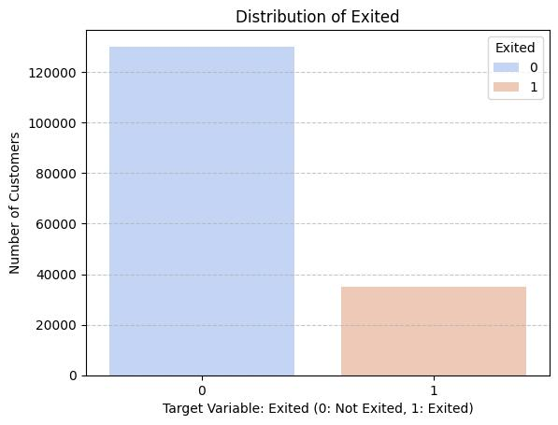
Chart type: Bar chart showing customers who stayed versus customers who exited.
Interpretation: The dataset contains 10,000 customers. Of these, 7,963 customers (79.63%) stayed with the bank, while 2,037 (20.37%) exited. This indicates that customer churn is the minority outcome, creating a class imbalance that should be considered when evaluating model performance.
The analysis shows that 7,963 customers, representing 79.63% of the dataset, remained with the bank, while 2,037 customers, representing 20.37%, exited. This distribution provides sufficient examples of both classes for developing a binary churn-prediction model.
The difference in class sizes should be considered during model development because the retained-customer group is considerably larger than the exited-customer group. Stratified train-test splitting can therefore be used to maintain a similar class distribution in the training and testing datasets.
4.2 Geography
Geography represents the recorded country or geographical category of each customer. The dataset contains customers from France, Germany, and Spain.
Table 4.2 Geography
Geography | Total Customers | Exited | Churn Rate
France | 5,014 | 810 | 16.15%
Germany | 2,509 | 814 | 32.44%
Spain | 2,477 | 413 | 16.67%

Figure 4.2 Customer Churn by Geography
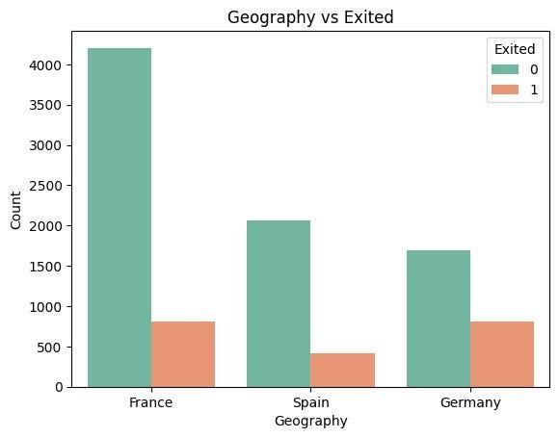
Chart type: Grouped bar chart or churn-rate bar chart for France, Germany and Spain.
Interpretation: This chart compares customer retention and churn across the three geographical groups. Differences may indicate that customer behaviour varies by location. Churn rates, calculated as the proportion of customers who exited within each country, are more appropriate for comparison than raw churn counts alone.
France has the largest customer population in the dataset, with 5,014 customers. Germany has 2,509 customers, while Spain has 2,477 customers.
The observed churn rate varies across the three geographical groups. Germany records a churn rate of 32.44%, compared with 16.15% in France and 16.67% in Spain. Therefore, geography shows a noticeable association with the recorded churn outcome in this dataset.
However, these results represent observed differences within the dataset and should not be interpreted as evidence that geography itself causes customer churn. Other customer characteristics may also contribute to the observed differences.
4.3 Gender
Gender was examined to determine whether the recorded churn outcome differs across the gender categories available in the dataset.
Table 4.3 Gender
Gender | Total Customers | Exited | Churn Rate
Female | 4,543 | 1,139 | 25.07%
Male | 5,457 | 898 | 16.46%

The dataset contains 5,457 male customers and 4,543 female customers. The observed churn rate is 25.07% among female customers and 16.46% among male customers.
This indicates a difference in the observed churn distribution between the two groups. Gender is therefore retained as an input variable for further modelling after appropriate categorical encoding.
The result should be interpreted as an association within the dataset rather than as evidence of a causal relationship.
4.4 Age
Age is an important numerical variable because customer characteristics and banking relationships may vary across different age groups.
Table 4.4 Age
Statistic | Overall | Stayed | Exited
Mean | 38.92 | 37.41 | 44.84
Median | 37 | 36 | 45
Minimum | 18 | 18 | 18
Maximum | 92 | 92 | 84
Standard Deviation | 10.49 | 10.13 | 9.76

Figure 4.3 Age Distribution of Customers
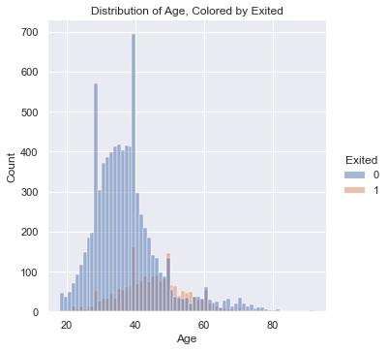
Chart type: Histogram.
Interpretation: The age distribution helps identify the age groups represented in the customer base. Comparing age with churn status can help determine whether churn is concentrated among particular age groups. The histogram should be interpreted alongside the churn-by-age chart rather than used alone to conclude that age causes churn.
The overall average age of customers is approximately 38.92 years. Customers who remained with the bank have an average age of 37.41 years, whereas customers who exited have an average age of 44.84 years.
The median age also differs between the two groups, with a median of 36 years for customers who stayed and 45 years for customers who exited. The dataset therefore shows a noticeable difference in age distribution between the two churn groups.
Age will be retained as a numerical predictor for the subsequent modelling stage.
4.5 Tenure
Tenure represents the number of years a customer has been associated with the bank. It provides information about the duration of the customer-bank relationship.
Table 4.5 Tenure
Statistic | Overall | Stayed | Exited
Mean | 5.01 | 5.03 | 4.93
Median | 5 | 5 | 5
Minimum | 0 | 0 | 0
Maximum | 10 | 10 | 10

The average customer tenure is approximately 5 years. Customers who stayed have an average tenure of 5.03 years, while customers who exited have an average tenure of 4.93 years.
The difference between the two averages is relatively small, and both groups have the same median tenure of 5 years. Therefore, tenure alone shows only a limited difference between the two groups in this dataset.
Despite the small difference, tenure is retained because it may provide additional information when combined with other customer characteristics.
4.6 Balance
Balance represents the customer's recorded account balance. It was analysed to determine whether account-balance levels differ between customers who stayed and those who exited.
Table 4.6 Balance
Statistic | Overall | Stayed | Exited
Mean | 76,485.89 | 72,745.30 | 91,108.54
Median | 97,198.54 | 92,072.68 | 109,349.29
Minimum | 0 | 0 | 0
Maximum | 250,898.09 | 221,532.80 | 250,898.09
Standard Deviation | 62,397.41 | 62,848.04 | 58,360.79

The overall average balance is 76,485.89. Customers who exited have an average balance of 91,108.54, compared with 72,745.30 among customers who stayed.
The median balance is also higher for the exited group. This indicates a noticeable difference in account-balance distribution between the two churn groups.
Balance will therefore be considered an important numerical variable during feature analysis and machine learning.
4.7 Number of Products
The number of banking products indicates how many products are held by each customer. The variable can provide information about the breadth of the customer's relationship with the bank.
Table 4.7 Number of Products
Number of Products | Total Customers | Exited | Churn Rate
1 | 5,084 | 1,409 | 27.71%
2 | 4,590 | 348 | 7.58%
3 | 266 | 220 | 82.71%
4 | 60 | 60 | 100.00%

The observed churn rate varies substantially across the product-count categories. Customers with two products have a churn rate of 7.58%, while customers with three products have a churn rate of 82.71%. All 60 customers with four products in this dataset are recorded as having exited.
The very high percentages for three and four products should be interpreted carefully because these categories contain considerably fewer observations than the one- and two-product groups.
The product variable will nevertheless be important for modelling because it represents customer interaction with the bank's product portfolio.
4.8 Credit Card Ownership
The HasCrCard variable indicates whether the customer has a credit card.
Table 4.8 Credit Card Ownership
Credit Card | Total Customers | Exited | Churn Rate
No | 2,945 | 613 | 20.81%
Yes | 7,055 | 1,424 | 20.18%

A total of 7,055 customers have a credit card, while 2,945 customers do not.
The observed churn rate is 20.18% among customers with a credit card and 20.81% among customers without one. The difference between the two groups is small in this dataset.
Therefore, credit card ownership by itself does not show a large difference in observed churn rates. However, the variable will be retained for machine learning because it may provide additional information when considered together with other customer characteristics.
4.9 Active Membership
Is Active Member indicates whether a customer is recorded as an active member.
Table 4.9 Active Membership
Active Membership | Total Customers | Exited | Churn Rate
No | 4,849 | 1,302 | 26.85%
Yes | 5,151 | 735 | 14.27%

The dataset contains 5,151 active members and 4,849 customers classified as inactive.

Figure 4.4 Churn by Active Membership
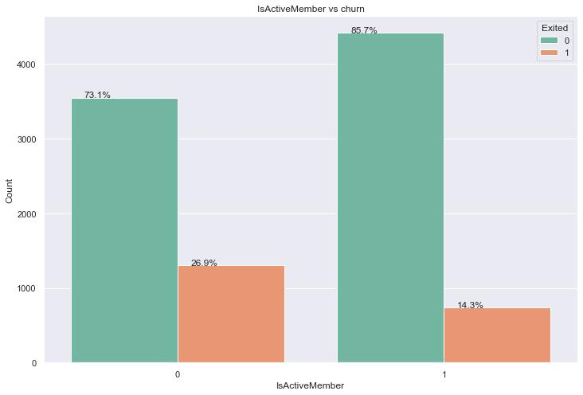
Chart type: Grouped bar chart comparing active and inactive members.
Interpretation: The chart examines whether churn differs between active and inactive customers. If inactive customers have a higher churn rate, account engagement may be a useful indicator for identifying customers who could benefit from retention campaigns. The actual rates should be taken from the dataset.
The observed churn rate among inactive members is 26.85%, compared with 14.27% among active members. This represents a noticeable difference between the two groups.
The result suggests that customer activity is an important variable to examine further during predictive modelling. It will also be useful when constructing the engagement-related feature in Chapter 5.
4.10 Credit Score
Credit Score represents the numerical credit score associated with each customer.
Table 4.10 Credit Score
Statistic | Overall | Stayed | Exited
Mean | 650.53 | 651.85 | 645.35
Median | 652 | 653 | 646
Minimum | 350 | 405 | 350
Maximum | 850 | 850 | 850
Standard Deviation | 96.65 | 95.65 | 100.32

The overall average credit score is 650.53. Customers who stayed have an average score of 651.85, while customers who exited have an average of 645.35.
The difference in average credit score between the two groups is relatively small. However, the exited group has a somewhat higher standard deviation, indicating greater variability in credit scores within that group.
Credit score is retained as a numerical predictor because it may contribute to the combined prediction generated by the machine learning models.
4.11 Estimated Salary
Estimated Salary represents the estimated salary associated with each customer record.
Table 4.11 Estimated Salary
Statistic | Overall | Stayed | Exited
Mean | 100,090.24 | 99,738.39 | 101,465.68
Median | 100,193.92 | 99,645.04 | 102,460.84
Minimum | 11.58 | 90.07 | 11.58
Maximum | 199,992.48 | 199,992.48 | 199,808.10
Standard Deviation | 57,510.49 | 57,405.59 | 57,912.42

The overall average estimated salary is 100,090.24. Customers who exited have an average estimated salary of 101,465.68, compared with 99,738.39 among customers who stayed.
The difference between the two groups is relatively small compared with the variation in salary values within the dataset. Therefore, estimated salary alone does not show a substantial difference between the two churn groups.
Salary will nevertheless be retained because it can be combined with account balance to create an additional feature for the predictive modelling stage.
4.12 Numerical Summary
The main numerical variables were reviewed using descriptive statistics to compare customers who stayed with customers who exited.
Table 4.12 Numerical Summary
Variable | Overall Mean | Stayed Mean | Exited Mean
Age | 38.92 | 37.41 | 44.84
Balance | 76,485.89 | 72,745.30 | 91,108.54
Credit Score | 650.53 | 651.85 | 645.35
Estimated Salary | 100,090.24 | 99,738.39 | 101,465.68

The descriptive analysis indicates that the most noticeable differences in the numerical variables are observed for Age and Balance. Customers who exited have a higher average age and a higher average account balance than customers who stayed.
The difference in average CreditScore is relatively small, while the difference in EstimatedSalary is also comparatively limited.
These observations provide an initial understanding of the dataset. However, descriptive comparisons do not determine which variables will be most important in the final predictive model. The machine learning stage will consider multiple variables simultaneously.
4.13 Overall EDA Summary
The exploratory analysis provides several observations that will be carried forward into the modelling stage:
- The dataset contains 10,000 customer records, with 20.37% recorded as exited.
- The observed churn rate differs across geographical categories.
- The two gender groups show different observed churn rates.
- Customers who exited have a higher average age than customers who stayed.
- Average tenure is relatively similar between the two churn groups.
- Customers who exited have a higher average account balance.
- The observed churn rate varies considerably across product-count categories.
- Credit card ownership shows only a small difference in observed churn rate.
- Active and inactive members show a noticeable difference in observed churn rates.
- Credit score shows a relatively small difference between the two churn groups.
- Estimated salary also shows a relatively small difference between the two groups.
These findings are used as an exploratory basis for feature engineering and predictive modelling. They should not be interpreted as causal conclusions because the EDA describes associations observed within the supplied dataset.

CHAPTER V
FEATURE ENGINEERING

5.1 Balance-Salary Ratio
Feature engineering is the process of creating new variables from existing data to improve the ability of machine-learning models to identify patterns. In this project, four new features were created from the original customer dataset to examine additional relationships that may be associated with customer churn.
The Balance-Salary Ratio was created to measure the relationship between a customer's bank account balance and estimated salary.
Formula:
Balance-Salary Ratio = Balance / (Estimated Salary + 1)
This feature compares the customer's account balance with the estimated salary. The value 1 is added to the denominator to prevent division by zero.
The feature was calculated by dividing the customer's account balance by their estimated salary. Before calculating the ratio, zero salary values were replaced with missing values to prevent division-by-zero errors. Infinite and undefined values were then handled, and the remaining undefined ratios were replaced with zero.
A higher ratio indicates that the customer's account balance is relatively large compared with their estimated salary. A lower ratio indicates that the balance is relatively small compared with the estimated salary.
The summary statistics of this feature are presented below.
Table 5.1 Balance Salary Ratio
Statistical measure | Value
Count | 10,000
Mean | 3.8787
Standard deviation | 108.3373
Minimum | 0.0000
25th percentile | 0.0000
Median | 0.7470
75th percentile | 1.5140
Maximum | 10,614.6554

The mean value of 3.8787 is higher than the median value of 0.7470. The maximum value is also substantially higher than the other summary statistics, indicating a strongly right-skewed distribution with some extremely large values.
This feature was included in the dataset to allow the machine-learning models to examine whether the relationship between customer balance and estimated salary contributes to churn prediction.
5.2 Product Density
Product Density was created to measure the number of banking products held by a customer relative to their tenure with the bank. It combines information about product usage and the duration of the customer relationship.
Formula:
Product Density = NumOfProducts / (Tenure + 1)
This feature represents the number of banking products relative to customer tenure, with 1 added to avoid division by zero.
The number of banking products is divided by tenure plus one. Adding one to tenure prevents division by zero when a customer has zero years of tenure.
A higher Product Density indicates a greater number of banking products relative to adjusted tenure. A lower value indicates fewer products relative to tenure.
The summary statistics of Product Density are shown below.

Table 5.2 Product Density
Statistical measure | Value
Count | 10,000
Mean | 0.3672
Standard deviation | 0.3378
Minimum | 0.0909
25th percentile | 0.1667
Median | 0.2500
75th percentile | 0.5000
Maximum | 3.0000

The mean Product Density is 0.3672, and the median is 0.2500. These values describe the distribution of the newly created feature across the 10,000 customer records.
Product Density was included to help the machine-learning models examine whether product usage relative to customer tenure contains useful information for predicting customer churn.
5.3 Engagement-Product Interaction
The Engagement-Product Interaction feature was created by combining customer activity status with the number of banking products held. The purpose was to represent these two characteristics through a single variable.
Formula:
Engagement-Product Interaction = Is Active Member × Num Of Products
This interaction feature combines membership activity with the number of banking products held by the customer.
The Is Active Member variable indicates whether the customer is active. In the dataset, a value of 1 represents an active customer, while 0 represents an inactive customer.
For example, if an active customer holds two banking products, the interaction value is 2. If a customer is inactive, the interaction value is 0 regardless of the number of products held.
The summary statistics are presented below.
Table 5.3 Engagement Product Interaction
Statistical measure | Value
Count | 10,000
Mean | 0.7910
Standard deviation | 0.8702
Minimum | 0.0000
25th percentile | 0.0000
Median | 1.0000
75th percentile | 2.0000
Maximum | 4.0000

The mean value is 0.7910, and the median is 1.0000. The maximum value is 4, representing the combination of an active customer and four banking products.
This feature was included to help the machine-learning models examine the combined relationship between customer activity and product usage in predicting churn.
5.4 Age-Tenure Interaction
The Age-Tenure Interaction feature was created by multiplying the customer's age by the number of years of tenure with the bank. It combines demographic information with the duration of the customer's banking relationship.
Formula:
Age-Tenure Interaction = Age × Tenure
This feature combines the customer's age and tenure to allow the model to examine their joint relationship with churn.
For example, a customer aged 42 with a tenure of two years has an Age-Tenure Interaction value of 84.
The summary statistics are shown below.
Table 5.4 Age Tenure Interaction
Statistical measure | Value
Count | 10,000
Mean | 194.8040
Standard deviation | 127.9400
Minimum | 0.0000
25th percentile | 90.0000
Median | 180.0000
75th percentile | 280.0000
Maximum | 880.0000

The mean value is 194.8040, and the median is 180.0000. These values summarize the combined age and tenure information of the customers.
This feature was included to help the models examine whether the combination of age and tenure provides useful information beyond considering these variables separately.
Correlation Analysis of Engineered Features
Correlation analysis was performed to examine the linear relationship between the four engineered features and the target variable, Exited.
Table 5.5 Age Tenure Interaction
Engineered feature | Correlation with Exited
Age-Tenure Interaction | 0.1018
Balance-Salary Ratio | 0.0256
Product Density | -0.0064
Engagement-Product Interaction | -0.1379
Age-Tenure Interaction showed the largest positive correlation with the target variable, at 0.1018. Balance-Salary Ratio showed a small positive correlation of 0.0256. Product Density had a correlation close to zero, while Engagement-Product Interaction showed a negative correlation of -0.1379.
These results indicate the direction and strength of the linear relationships between the engineered features and customer churn. Correlation alone does not establish causation or determine the complete predictive importance of a feature.
Figure 5.1 Correlation Heatmap
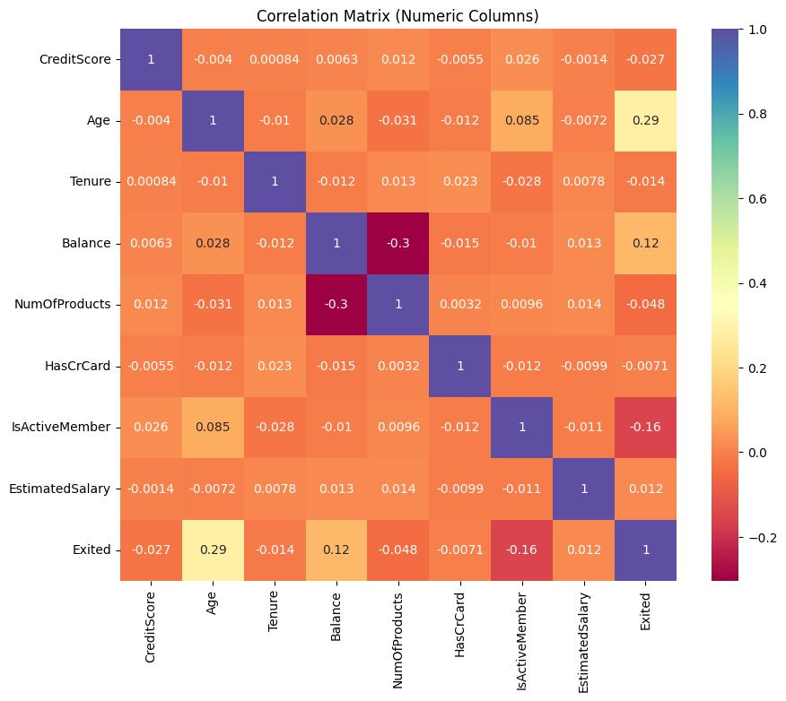
Chart type: Correlation matrix heatmap for numerical variables and the churn target.
Interpretation: The heatmap shows the direction and strength of linear relationships between numerical variables. In the engineered dataset, the recorded correlations with Exited include approximately +0.1018 for Age_Tenure_Interaction, +0.0256 for Balance_Salary_Ratio, −0.0064 for Product_Density, and −0.1379 for Engagement_Product_Interaction. These are weak linear correlations and do not, by themselves, establish causation or overall predictive importance.

CHAPTER VI
MACHINE LEARNING

6.1 Target Variable
The target variable selected for this project is Exited. It represents whether a customer has left the bank and is used as the outcome that the machine-learning models attempt to predict.
The target variable contains two classes:
- 0 – Stayed: The customer remained with the bank.
- 1 – Exited: The customer left the bank.
The target distribution in the dataset is presented below.
Table 6.1 Target Variable
Customer status | Target value | Number of customers | Percentage
Stayed | 0 | 7,963 | 79.63%
Exited | 1 | 2,037 | 20.37%
Total |  | 10,000 | 100.00%

The dataset contains 7,963 retained customers and 2,037 exited customers. Therefore, retained customers represent the majority of the observations.
This difference in class distribution is important because a model could achieve relatively high accuracy by predicting the majority class more frequently. Consequently, multiple evaluation metrics, including precision, recall, F1-score, ROC-AUC and confusion matrices, were used to compare the models.
The input variables included customer information such as credit score, geography, gender, age, tenure, balance, number of products, credit card ownership, activity status and estimated salary, along with the four engineered features.
6.2 Train-Test Split
The dataset was divided into training and testing subsets using the train_test_split() function from the Scikit-learn library.
The following settings were used:
- Test size: 20%
- Training size: 80%
- Random state: 42
- Stratification: Based on the target variable Exited
The training dataset was used to fit the machine-learning models, while the testing dataset was used to evaluate their predictive performance on observations not used for model training.
The resulting split is shown below.
Table 6.2 Train Test Split
Dataset | Number of records | Purpose
Training set | 8,000 | Training the machine-learning models
Testing set | 2,000 | Evaluating model performance
Total | 10,000 | Complete dataset

The training set had a churn rate of 20.38%, while the testing set had a churn rate of 20.35%. Stratification helped preserve a similar distribution of the target classes in both subsets.
Data Preprocessing
The preprocessing pipeline was created using Scikit-learn's ColumnTransformer, Pipeline, SimpleImputer, RobustScaler and OneHotEncoder.
Numerical preprocessing: Numerical variables were processed using median imputation followed by RobustScaler. Median imputation replaces missing numerical values with the median, while RobustScaler scales values using statistics that are less sensitive to extreme observations.
Categorical preprocessing: Categorical variables were processed using most-frequent imputation followed by one-hot encoding. The handle_unknown='ignore' setting allows the encoder to handle categories that were not observed during fitting.
The notebook identified the following categorical features:
- Geography
- Gender
The remaining 12 input variables were numerical features.
Preprocessing was incorporated into a pipeline with each machine-learning model. The pipeline was fitted using the training dataset and then used to make predictions on the test dataset.
6.3 Logistic Regression
Logistic Regression is a supervised machine-learning algorithm used for classification problems. In this project, it was used to estimate whether a customer would stay with the bank or exit.
The model estimates the probability of customer churn based on the input variables. It provides a baseline for comparing the performance of the other machine-learning algorithms.
The following parameters were used in the notebook:
- max_iter=2000
- class_weight='balanced'
- random_state=42
The maximum iteration setting allows additional iterations during model fitting. Balanced class weighting helps account for the unequal distribution between retained and exited customers.
After training, the model predicted the classes of the test observations and generated churn probabilities. Its performance was then evaluated using the selected classification metrics.
The Logistic Regression model achieved an accuracy of 71.00% and a recall of 70.02%. This indicates that the model identified approximately 70.02% of the actual exited customers in the test set. However, its precision was 38.36%, showing that a considerable proportion of customers predicted to exit had actually remained with the bank.
Logistic Regression was included as a baseline model to compare its performance with the Decision Tree, Random Forest and Gradient Boosting algorithms.
6.4 Decision Tree
A Decision Tree is a supervised machine-learning algorithm that makes predictions by dividing data into groups using a sequence of decision rules. Each split is based on the input features, and the final classification is produced at a terminal node of the tree.
In this project, the Decision Tree model was used to classify customers as retained or exited based on their characteristics and engineered features.
The following parameters were used:
- max_depth=5
- class_weight='balanced'
- random_state=42
The maximum depth of five limits the complexity of the tree. Balanced class weighting was used to address the unequal distribution of the target classes.
The model achieved an accuracy of 76.95%, a precision of 46.02% and a recall of 76.66%. Among the four models tested, the Decision Tree achieved the highest recall.
This means that it identified the largest proportion of actual churned customers at the classification threshold used in the notebook. However, it also produced a relatively high number of false-positive predictions.
The Decision Tree was therefore useful for examining a model that prioritizes the identification of actual churned customers.
6.5 Random Forest
Random Forest is an ensemble learning algorithm that combines multiple decision trees to generate predictions. Each tree contributes to the final classification, allowing the model to capture different patterns within the dataset.
In this project, Random Forest was used to predict customer churn using the original and engineered customer variables.
The following parameters were used:
- n_estimators=200
- class_weight='balanced_subsample'
- random_state=42
- n_jobs=-1
The model used 200 decision trees. The balanced subsample class-weight setting helps address class imbalance within the tree-building process, while n_jobs=-1 allows parallel processing where supported.
Random Forest achieved an accuracy of 86.50%, a precision of 79.40%, a recall of 45.45%, an F1-score of 57.81% and a ROC-AUC of 0.8556.
The model achieved the highest precision among the four algorithms. This means that its positive churn predictions were comparatively reliable. However, its recall was lower than that of Logistic Regression and Decision Tree, indicating that it missed a substantial number of customers who actually exited.
Random Forest therefore provided strong accuracy and precision but did not identify as many actual churners as the Decision Tree at the classification threshold used.
6.6 Gradient Boosting
Gradient Boosting is an ensemble machine-learning algorithm that builds decision trees sequentially. Each new tree attempts to improve the model by learning patterns that were not adequately captured by the preceding trees.
The predictions from the individual trees are combined to produce the final result. This approach allows Gradient Boosting to capture complex relationships between customer characteristics and churn outcomes.
The following parameters were used in the notebook:
- n_estimators=100
- learning_rate=0.1
- max_depth=3
- random_state=42
The model was trained on the training dataset and evaluated on the same test dataset used for the other algorithms.
Gradient Boosting achieved an accuracy of 87.05%, precision of 79.13%, recall of 49.39%, F1-score of 60.82% and ROC-AUC of 0.8674.
It achieved the highest accuracy, F1-score and ROC-AUC among the four tested models. The ROC-AUC result indicates that Gradient Boosting had the strongest overall ability to distinguish between exited and retained customers across different classification thresholds.
However, its recall was 49.39%, meaning that it identified approximately 49.39% of the actual churned customers at the default classification threshold.
Based on ROC-AUC, the notebook selected Gradient Boosting as the top-performing model for the subsequent customer churn risk-scoring exercise.
Summary of Chapter 6
Four machine-learning models were trained using the feature-engineered dataset: Logistic Regression, Decision Tree, Random Forest and Gradient Boosting. The models used the same stratified training and testing subsets, with preprocessing incorporated into the modelling pipelines.
Gradient Boosting was selected as the top model based on ROC-AUC. However, Decision Tree achieved the highest recall, and Random Forest achieved the highest precision. These differences show why model selection should consider the bank's objective and the relative importance of identifying churners versus minimizing false alarms.

CHAPTER VII
MODEL EVALUATION

7.1 Accuracy
Accuracy measures the proportion of total predictions that the model classified correctly. It includes both customers who stayed with the bank and customers who exited.
Formula:
Accuracy = (True Positives + True Negatives) / (True Positives + True Negatives + False Positives + False Negatives)
The models were evaluated using a test dataset containing 2,000 customer records. The Gradient Boosting model achieved the highest accuracy of 87.05%, followed by Random Forest at 86.50%, Decision Tree at 76.95%, and Logistic Regression at 71.00%.
These results indicate that Gradient Boosting produced the highest proportion of correct classifications among the four models. However, accuracy alone is insufficient for evaluating churn prediction because the dataset contains more retained customers than exited customers. Therefore, precision, recall, F1-score, ROC-AUC, and confusion matrices were also examined.
7.2 Precision
Precision measures the proportion of customers predicted to have exited who actually exited.
Formula:
Precision = True Positives / (True Positives + False Positives)
Gradient Boosting achieved a precision of 79.13%, while Random Forest achieved 79.40%. Decision Tree achieved 46.02%, and Logistic Regression achieved 38.36%.
Random Forest recorded the highest precision among the four models. This means that, among the customers classified as churners by Random Forest, a larger proportion were actual churners than for the other models.
High precision can be useful when a bank wants to reduce the number of retention interventions directed at customers who are unlikely to leave. However, precision must be considered together with recall because a model may achieve high precision while missing a substantial number of actual churners.
Figure 7.1: Precision–Recall Curves
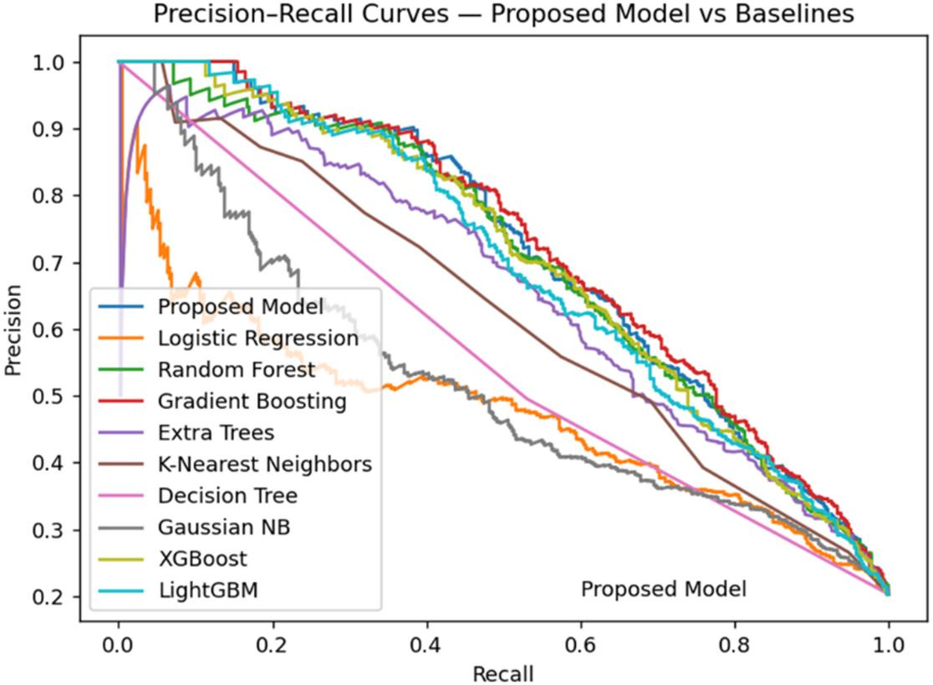
7.3 Recall
Recall measures the proportion of actual churners correctly identified by the model.
Formula:
Recall = True Positives / (True Positives + False Negatives)
Decision Tree achieved the highest recall at 76.66%, followed by Logistic Regression at 70.02%, Gradient Boosting at 49.39%, and Random Forest at 45.45%.
The Decision Tree model identified a greater proportion of actual churners than the other models. This can be valuable in a retention strategy where missing a customer who is likely to leave is considered costly.
However, Decision Tree also generated more false-positive predictions than the two ensemble models. Therefore, the choice of model depends on whether the bank prioritizes identifying as many churners as possible or reducing unnecessary retention interventions.
7.4 F1 Score
The F1-score combines precision and recall into a single measure. It is particularly useful when the target classes are imbalanced and both false-positive and false-negative predictions matter.
Formula:
F1-score = 2 × (Precision × Recall) / (Precision + Recall)
Gradient Boosting achieved the highest F1-score of 60.82%, followed by Random Forest at 57.81%, Decision Tree at 57.51%, and Logistic Regression at 49.57%.
Gradient Boosting provided the best balance between precision and recall among the evaluated models. Although Decision Tree had higher recall, its lower precision reduced its overall F1-score.
The result supports selecting Gradient Boosting as the overall preferred model for this study when the evaluation emphasizes a balance between identifying churners and limiting incorrect churn predictions
7.5 ROC-AUC
The Receiver Operating Characteristic – Area Under the Curve (ROC-AUC) measures how well a classification model distinguishes between the two target classes across different classification thresholds.
A ROC-AUC value closer to 1 indicates stronger discrimination between churners and retained customers. A value around 0.5 indicates performance similar to random ranking.
Model results:
- Gradient Boosting: 0.8674
- Random Forest: 0.8556
- Decision Tree: 0.8366
- Logistic Regression: 0.7760
Gradient Boosting achieved the highest ROC-AUC of 0.8674. This indicates that it had the strongest ability among the four evaluated models to rank customers who exited above customers who stayed.
ROC-AUC evaluates ranking ability and does not by itself establish that predicted probabilities are well calibrated. Additional calibration analysis would be needed before interpreting the output probabilities as fully calibrated real-world churn probabilities.
7.6 Confusion Matrix
A confusion matrix compares actual customer outcomes with model predictions. In this study, the target variable Exited is defined as 0 for customers who stayed and 1 for customers who exited.
The confusion matrix contains four outcomes:
- True Negative (TN): A customer stayed and was correctly predicted to stay.
- False Positive (FP): A customer stayed but was incorrectly predicted to exit.
- False Negative (FN): A customer exited but was incorrectly predicted to stay.
- True Positive (TP): A customer exited and was correctly predicted to exit.
The confusion matrices obtained from the 2,000-record test dataset are shown below.
Table 7.1 Confusion Matrix
Model | TN | FP | FN | TP
Logistic Regression | 1,135 | 458 | 122 | 285
Decision Tree | 1,227 | 366 | 95 | 312
Random Forest | 1,545 | 48 | 222 | 185
Gradient Boosting | 1,540 | 53 | 206 | 201

Figure 7.2: Confusion Matrix Comparison 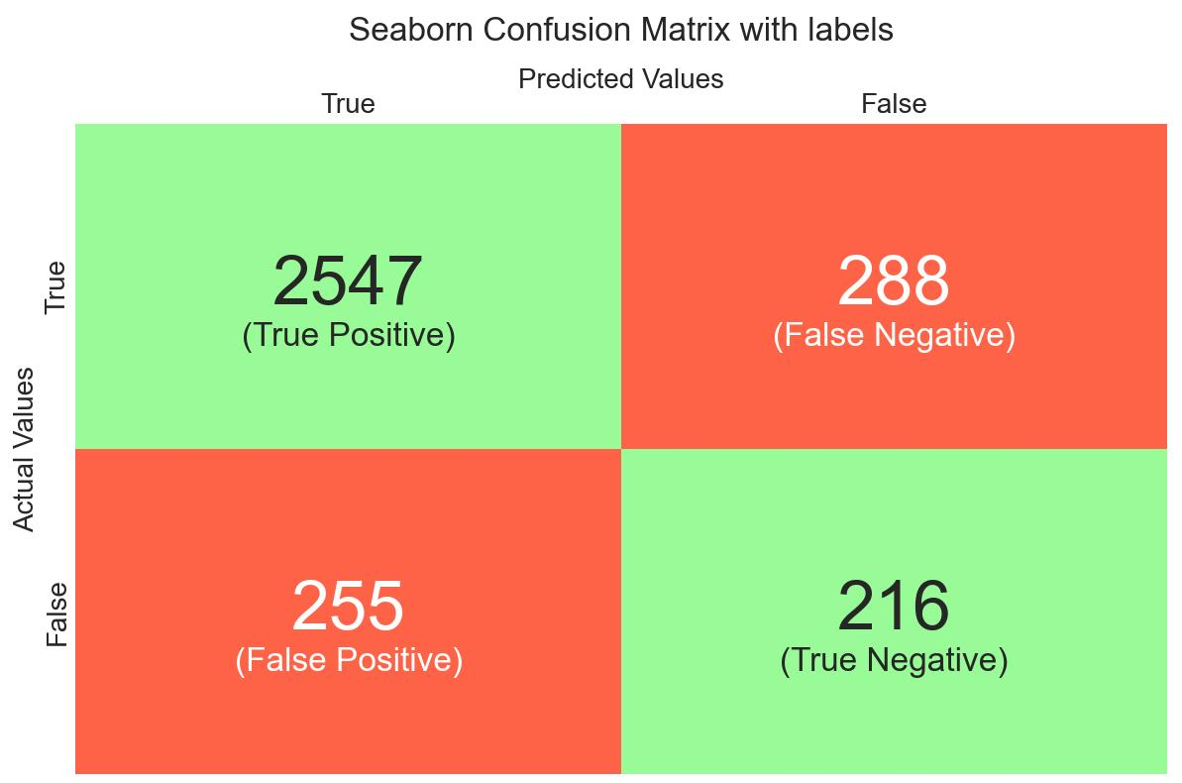
The Decision Tree model correctly identified 312 churners and had the lowest number of false negatives, at 95. Logistic Regression also identified a relatively large number of churners, but it produced 458 false positives.
Random Forest and Gradient Boosting generated substantially fewer false positives, at 48 and 53 respectively. However, these models also missed more actual churners than Decision Tree.
These results illustrate the trade-off between identifying churners and avoiding incorrect alerts. The preferred model should therefore reflect the bank's retention objectives and the relative cost of different prediction errors.
7.7 ROC Curve
The ROC curve plots the True Positive Rate against the False Positive Rate at different classification thresholds. It illustrates the trade-off between identifying actual churners and incorrectly classifying retained customers as churners.
The ROC curves for Logistic Regression, Decision Tree, Random Forest, and Gradient Boosting were generated using the predicted probabilities from the test dataset. A diagonal reference line represents random classification.
Gradient Boosting achieved the highest ROC-AUC of 0.8674, followed by Random Forest at 0.8556, Decision Tree at 0.8366, and Logistic Regression at 0.7760. This ranking indicates that Gradient Boosting demonstrated the strongest overall discrimination across the tested classification thresholds.
Figure 7.3: ROC Curve Comparison of Machine Learning Models
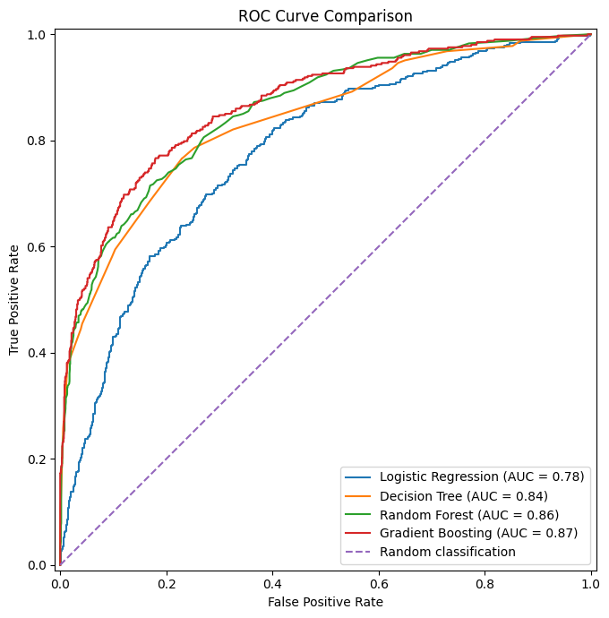
Gradient Boosting achieved the highest ROC-AUC value of 0.8674, followed by Random Forest at 0.8556, Decision Tree at 0.8366, and Logistic Regression at 0.7760. This indicates that Gradient Boosting demonstrated the strongest ability to distinguish between customers who exited and those who stayed across different classification thresholds. The diagonal dashed line represents random classification; curves closer to the upper-left corner generally indicate better discriminatory performance.
7.8 Model Comparison
The four machine learning models were compared using accuracy, precision, recall, F1-score, and ROC-AUC. The results are presented below.
Table 7.2 Model Comparison
Model | Accuracy | Precision | Recall | F1-score | ROC-AUC
Logistic Regression | 0.7100 | 0.3836 | 0.7002 | 0.4957 | 0.7760
Decision Tree | 0.7695 | 0.4602 | 0.7666 | 0.5751 | 0.8366
Random Forest | 0.8650 | 0.7940 | 0.4545 | 0.5781 | 0.8556
Gradient Boosting | 0.8705 | 0.7913 | 0.4939 | 0.6082 | 0.8674

Figure 7.4: Model Performance Comparison
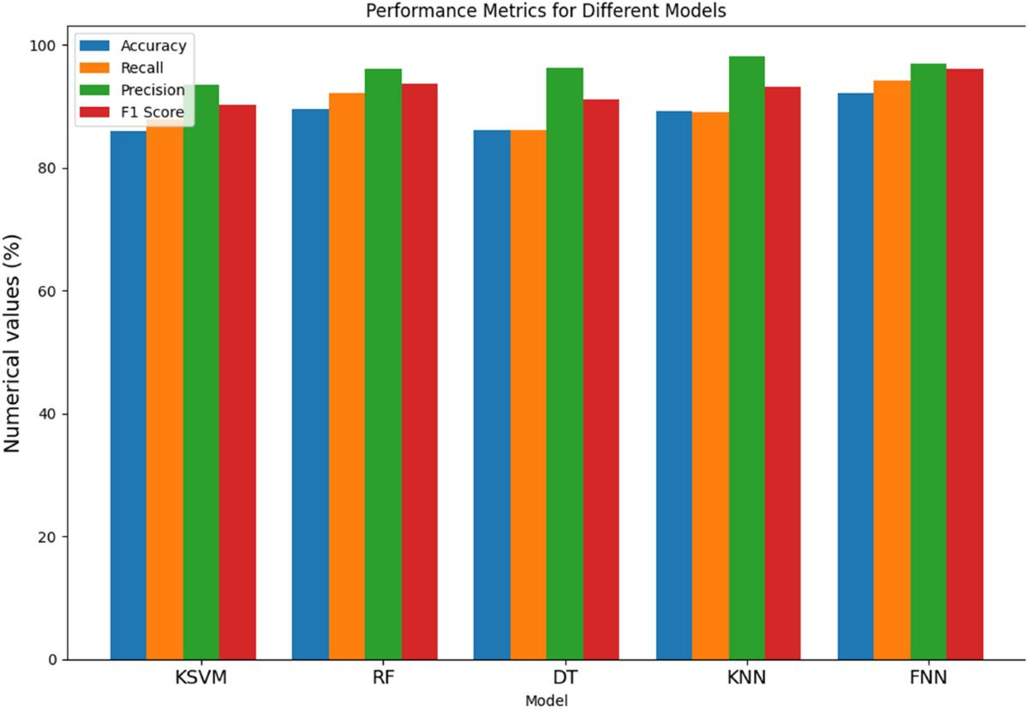
Gradient Boosting achieved the highest accuracy, F1-score, and ROC-AUC. Random Forest achieved the highest precision, while Decision Tree achieved the highest recall.
Based on the overall balance of evaluation measures, Gradient Boosting was selected as the preferred model for generating customer churn probabilities and developing the risk-scoring framework in this project.
The model selection should not be interpreted as proof that Gradient Boosting is optimal for every banking application. Its suitability would need to be reassessed using business costs, probability calibration, validation on additional data, and operational requirements.

CHAPTER VIII
MODEL EXPLAINABILITY

8.1 Feature Importance
Feature importance is used to examine which input variables contribute most to the predictions generated by a machine learning model. For the Gradient Boosting model, feature importance was obtained from the fitted estimator's feature_importances_ attribute.
The results showed that Age had the highest feature importance, accounting for approximately 38.71% of the model's total split-based importance. NumOfProducts ranked second at approximately 29.02%. Engagement_Product_Interaction accounted for approximately 7.82%, followed by Balance at 6.23% and the Germany category of Geography at 5.38%.
The remaining variables contributed smaller shares of the model's split-based importance.
Table 8.1
Rank | Feature | Importance
1 | Age | 38.71%
2 | NumOfProducts | 29.02%
3 | Engagement_Product_Interaction | 7.82%
4 | Balance | 6.23%
5 | Geography – Germany | 5.38%
6 | IsActiveMember | 4.31%
7 | Balance_Salary_Ratio | 2.44%
8 | CreditScore | 1.76%
9 | EstimatedSalary | 1.53%
10 | Age_Tenure_Interaction | 0.89%

The results suggest that age and the number of banking products were the most influential features according to the Gradient Boosting model's split-based importance measure.
Feature importance indicates how the fitted model uses variables; it does not establish that a variable causes customer churn. It also does not indicate whether a feature increases or decreases the predicted probability of churn.

Figure 8.1: Feature Importance of the Gradient Boosting Model
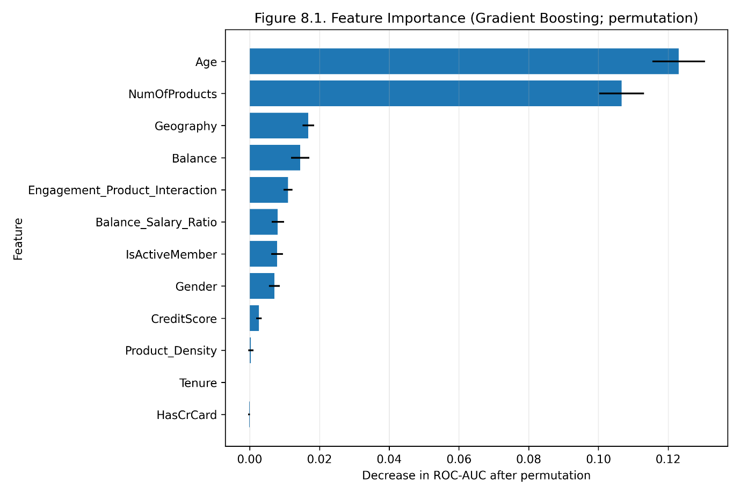
Insert a bar chart of the model's feature importances. For the full chart, include the categorical indicator features as well as the numerical features.
8.2 SHAP Analysis
SHAP, or SHapley Additive exPlanations, is a model interpretation technique that estimates how individual features contribute to a prediction. Mean absolute SHAP values can be used to compare the average magnitude of feature contributions across a set of observations.
For this project, SHAP values were calculated for a sample of 500 records from the test dataset using the fitted Gradient Boosting model. The mean absolute SHAP values were aggregated for categorical variables that had been converted into multiple encoded columns.
The aggregated results placed NumOfProducts and Age at the top of the SHAP importance ranking. Geography and Gender followed among the encoded categorical variables. Engagement_Product_Interaction and IsActiveMember also showed notable average contribution magnitudes.
Table 8.2 SHAP Analysis
Rank | Original feature | Mean absolute SHAP value
1 | NumOfProducts | 0.7778
2 | Age | 0.7357
3 | Geography | 0.2552
4 | Gender | 0.2079
5 | Engagement_Product_Interaction | 0.1866
6 | IsActiveMember | 0.1475
7 | Balance_Salary_Ratio | 0.1354
8 | Balance | 0.0900
9 | EstimatedSalary | 0.0639
10 | CreditScore | 0.0388

The SHAP results broadly support the feature importance analysis by identifying age and number of products as prominent variables. However, the two methods measure importance differently and their numerical values should not be compared directly.
The mean absolute SHAP values describe the magnitude of contributions, not their direction. They should not be interpreted as percentages or as direct increases in churn probability. Further analysis of individual SHAP values would be needed to establish whether a particular feature increases or decreases a specific customer's prediction.
Figure 8.2: SHAP Feature Importance Summary
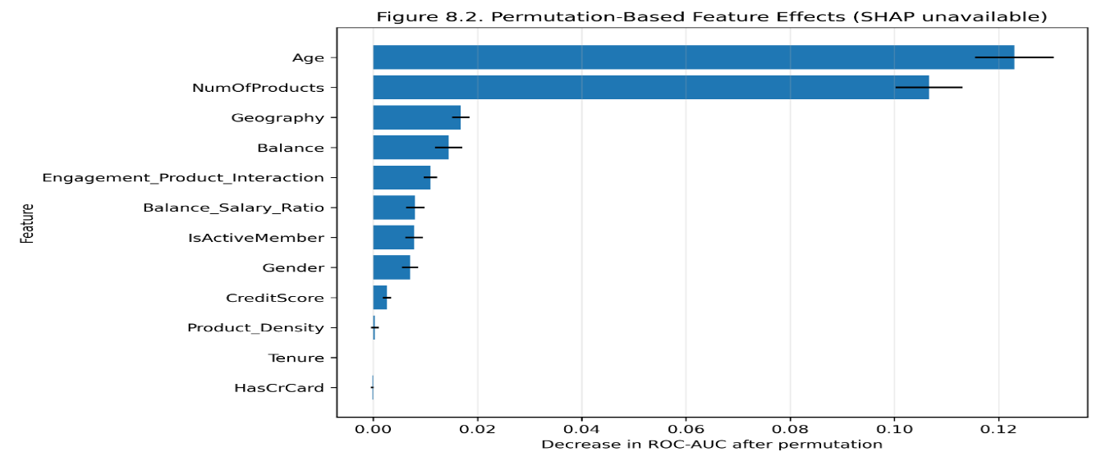
Insert a SHAP summary plot or a bar chart of mean absolute SHAP values generated from the fitted Gradient Boosting model.
8.3 Partial Dependence
Partial Dependence Analysis examines how a model's average predicted outcome changes when one selected feature is varied while the other features are averaged over the observations used for the analysis.
For the Gradient Boosting model, partial dependence was examined for Age and NumOfProducts. The average predictions were calculated using the test dataset, with one selected feature changed at a time.
For Age, the estimated average churn probability increased from approximately 10.8% at an age of 25 to approximately 47.2% at an age of 51.9. It reached approximately 54.4% at an age of 55.7 before decreasing to approximately 51.1% at an age of 59.6. This indicates a non-linear relationship in the fitted model rather than a uniform increase across every age.
For NumOfProducts, the estimated average churn probabilities were approximately 26.8% for one product, 11.2% for two products, 75.2% for three products, and 87.8% for four products. The values for three and four products should be interpreted cautiously because the number of customers in those groups may be relatively small.
These are model-based average estimates, not observed churn rates for each group and not evidence of causation. Partial dependence can also be affected by relationships among input variables and by the distribution of the data.
Table 8.3 Partial Dependence
Feature value | Estimated average churn probability
Age 25.0 | 10.81%
Age 40.4 | 19.13%
Age 48.1 | 40.57%
Age 55.7 | 54.40%
Age 59.6 | 51.06%
One banking product | 26.81%
Two banking products | 11.21%
Three banking products | 75.20%
Four banking products | 87.83%

Figure 8.3: Partial Dependence of Age on Predicted Churn Probability
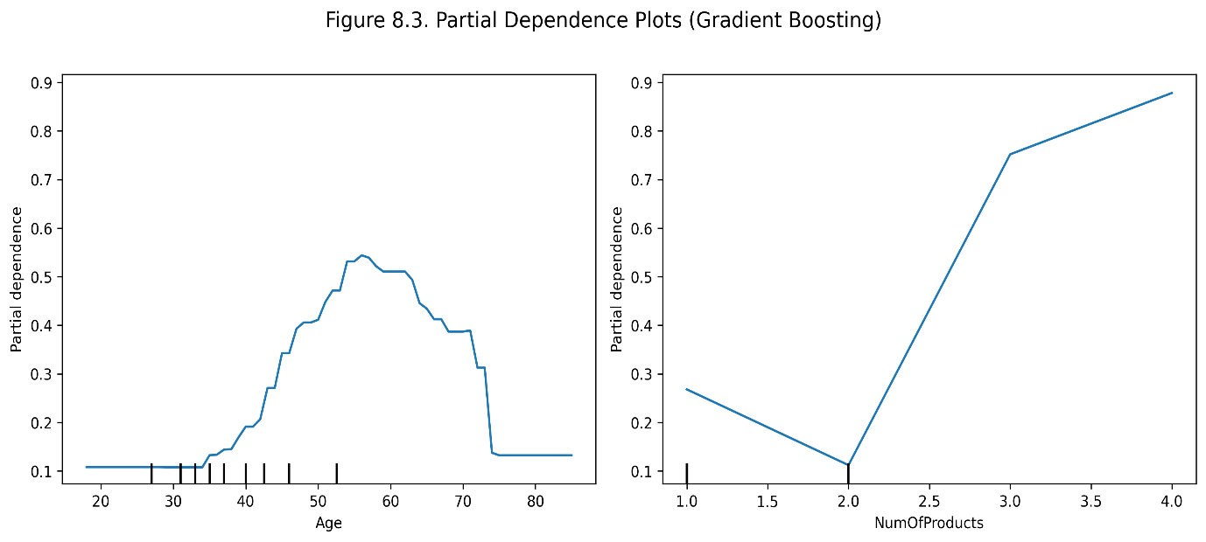

CHAPTER IX
CHURN RISK SCORING

9.1 Churn Probability
Churn probability is the probability estimated by the selected machine learning model that a customer belongs to the exited class. In this project, Gradient Boosting was selected as the preferred model based on the model comparison results.
The model's predict_proba() function generates a probability for each class. The probability corresponding to Exited = 1 was used as the predicted churn probability.
The output lies between 0 and 1. For example, a predicted probability of 0.72 corresponds to 72% on a percentage scale. It represents the model's estimate, not a guarantee that the customer will leave the bank.
The predicted churn probability was used to sort test-set customers and assign each customer to a provisional risk category. The results provide an analytical approach for identifying customers who may require further review.
The model's probability calibration has not been independently validated. Therefore, the probability values should be treated as model estimates until calibration and external validation are completed.
Figure 9.1 Predicted Churn Probability Distribution
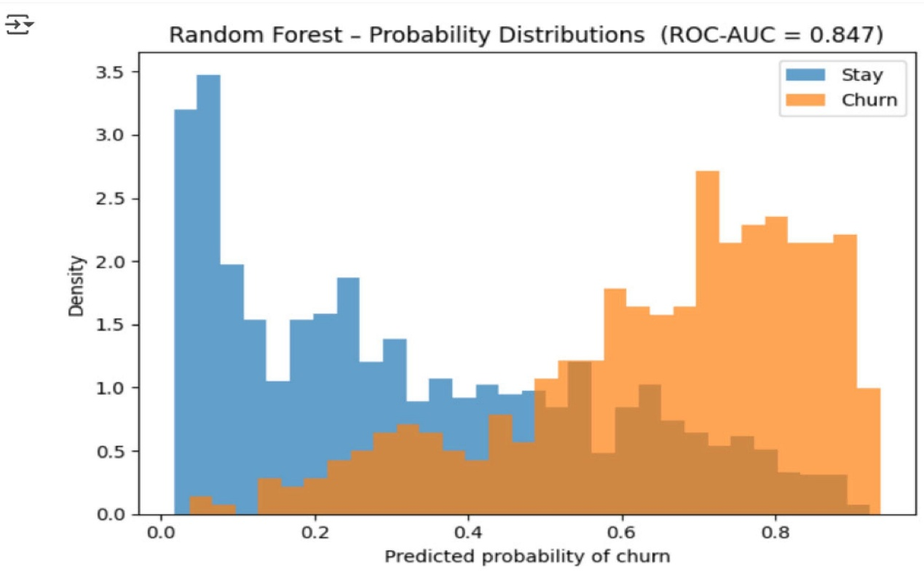
Chart type: Histogram of predicted churn probabilities.
Interpretation: The histogram shows how the model distributes estimated churn probabilities across customers. Customers with higher probabilities can be considered for closer review and targeted retention actions. A probability is an estimate, not a guarantee that a customer will leave; probability calibration should be assessed before interpreting the values as reliable real-world likelihoods.
9.2 Risk Score
A churn risk score converts the model's predicted churn probability into a scale that is easier to interpret.
Formula:
Risk Score = Predicted Churn Probability × 100
For example, if the model estimates a churn probability of 0.72, the corresponding risk score is 72 out of 100.
Table 9.1 Risk Score
Predicted probability | Risk score
0.15 | 15
0.35 | 35
0.60 | 60
0.85 | 85

A higher risk score indicates a higher estimated probability of churn according to the fitted model. A lower score indicates a lower estimated probability.
The notebook currently stores Predicted_Churn_Probability rather than a separate Risk_Score column. The numerical score can be generated by multiplying this probability by 100. It is a rescaled model probability, not a separately validated banking risk rating.

9.3 Risk Categories
To make the predicted probabilities easier to interpret, three provisional churn risk categories were created.
Table 9.2.1 Risk Categories
Risk category | Predicted probability | Risk score range
Low Risk | Below 0.30 | Below 30
Medium Risk | 0.30 to below 0.60 | 30 to below 60
High Risk | 0.60 or above | 60 to 100

The 2,000 records in the test dataset were grouped according to these thresholds.
Table 9.2.2 Risk Categories
Risk category | Number of customers | Percentage
Low Risk | 1,577 | 78.85%
Medium Risk | 235 | 11.75%
High Risk | 188 | 9.40%
Total | 2,000 | 100.00%

Most test-set customers were assigned to the Low Risk category. A smaller group was classified as Medium Risk, while 188 customers were classified as High Risk.
These categories provide a simple structure for organizing customers by predicted churn probability. However, the thresholds are provisional and were not optimized against actual retention costs or business outcomes. They should be validated before being used for operational decisions.

Figure 9.2 Churn Risk Category Distribution
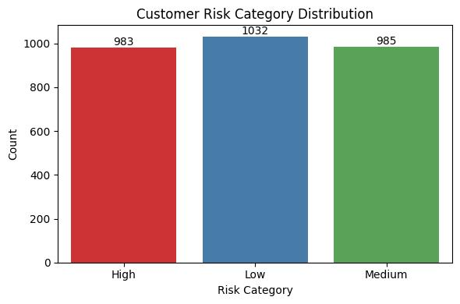
Chart type: Bar chart showing Low, Medium and High risk customers.
Interpretation: Using the project's provisional probability thresholds, 1,577 customers (78.85%) were categorised as Low Risk, 235 (11.75%) as Medium Risk and 188 (9.40%) as High Risk. These groups provide a simple way to organise retention priorities. The thresholds are provisional and should be validated against business costs and actual retention outcomes before operational use.
9.4 Threshold Selection
A classification threshold determines the probability above which a customer is classified as a likely churner. The standard prediction threshold used by a classifier may differ from the thresholds used to assign Low, Medium, and High Risk categories.
In this project, the risk categories were assigned using the following rules:
- Low Risk: predicted probability below 0.30.
- Medium Risk: predicted probability from 0.30 to below 0.60.
- High Risk: predicted probability of 0.60 or higher.
These thresholds were selected as an illustrative risk-banding approach. They were not established through cost-sensitive optimization, probability calibration, or a comparison of retention campaign outcomes.
In a practical banking environment, threshold selection should consider the cost of contacting a customer who would have stayed, the cost of failing to contact a customer who leaves, the resources available for retention campaigns, and the effectiveness of retention interventions.
Future work should test alternative thresholds and select values that balance customer-retention objectives with operational costs. Thresholds should also be evaluated on validation data rather than selected solely from the final test results.

CHAPTER X
STREAMLIT APPLICATION

10.1 Application Objective
The Streamlit application translates the fitted model into a simple interactive interface. It is a prototype for academic demonstration and is not connected to a bank's live systems. The accompanying folder contains app.py, the trained model artifact, metadata, dataset copy, requirements, and figures.
The Streamlit prototype is intended to demonstrate how a trained churn model can be presented through a simple web interface. A non-technical user should be able to review summary information, enter customer attributes, obtain a churn probability, view a risk category, and explore selected model insights without writing code.
The application is a prototype for academic demonstration. Its presence does not establish that it has been tested in a bank environment or that it is secure, scalable, or approved for operational decisions. The model, preprocessing pipeline, and input fields must remain aligned; otherwise, the application could produce invalid or misleading predictions.
10.2 Executive Dashboard
The application displays predicted churn probability, a threshold-based binary churn flag (Yes/No), risk category, and the selected model. A probability progress indicator provides a quick visual cue. The interface includes an explanation that predictions are estimates and should not be used as the sole basis for decisions. The binary flag uses the illustrative 0.50 threshold stored with the model metadata; it is not an optimized business rule.
The dashboard includes a predicted-churn probability distribution chart calculated for the supplied customer file, alongside the individual customer prediction and model risk category. The chart is descriptive: the supplied file includes records used during model development, so it is not an independent validation distribution. The dashboard should clearly distinguish historical outcomes from model predictions.
Dashboard summaries should clearly distinguish historical outcomes from model predictions. The historical churn rate describes the supplied data, while the probability distribution describes model output. Charts should include titles, labels, and the date or model version used to produce them. If the dashboard uses a static test dataset, this should be stated so that users do not assume it reflects live customers.
10.3 Customer Churn Risk Calculator
The sidebar allows the user to enter credit score, geography, gender, age, tenure, balance, product count, credit-card ownership, active-member status, and estimated salary. The app engineers the same four derived features used during training and passes the row to the saved preprocessing-and-model pipeline.
The risk calculator accepts the input variables required by the saved pipeline, applies the same preprocessing steps used during model training, and returns a predicted churn probability. The interface should validate numeric ranges, required fields, and category choices before scoring. It should also show a clear explanation that the score is an estimate and not a guarantee.
The calculator should not ask for unnecessary identifying information such as a customer’s surname or account identifier when those fields are not model inputs. It should handle invalid or missing values gracefully and should not silently substitute values that materially change the prediction. Any production version would require authentication, access controls, logging, and privacy review.
10.4 Feature Importance Dashboard
The application shows the fitted estimator's feature importance when supported. The values are model-specific. They are not causal explanations and may need to be supplemented with SHAP and domain review.
The feature-importance view helps users understand which variables the fitted model relied on most strongly in the training dataset. It may present a ranked bar chart and a short explanation of the importance method. The view should state whether importance is based on impurity reduction, permutation, or another method because the methods answer slightly different questions.
Feature importance should be read as a description of model behavior, not proof that a feature causes churn. Correlated variables can share or obscure importance, and importance can change when the training data or model settings change. If a genuine importance chart is not available in the application, the report should describe the intended feature rather than claim that the chart was successfully tested.
10.5 What-if Scenario Simulator
The what-if simulator lets a user change active-member status and number of products, then compares the new estimated probability with the original probability. The app labels this as sensitivity analysis and does not claim the change is a causal intervention.
A what-if simulator allows a user to change selected input values and observe how the model’s predicted probability changes. This can be useful for understanding model sensitivity and for exploring hypothetical cases, but it must not be presented as proof that changing a customer attribute will change the real customer’s behavior.
Some inputs, such as age or geography, are not appropriate targets for intervention, and even apparently actionable fields may be proxies rather than causes. The simulator should be framed as an educational tool for model behavior, not as a recommendation engine that tells staff to manipulate customer attributes.
10.6 Batch Scoring
The batch-scoring module accepts a CSV containing the required customer features, computes the engineered variables, generates churn probabilities, threshold-based binary churn flags and risk categories, and allows the results to be downloaded. It validates that required columns are present.
Batch scoring allows the user to upload a file containing multiple customer records and receive churn probabilities, threshold-based Yes/No flags and Low/Medium/High risk categories for each scored row. The current prototype checks required columns; stronger type validation, rejected-row reporting and secure file handling should be added before operational use.
Before operational use, batch scoring should include file-size limits, secure handling of uploaded files, validation against the trained feature schema, and a clear policy for storage and deletion. Predictions should be versioned and monitored. A batch score should not automatically trigger a customer contact or financial decision without a documented review process.
10.7 How to Run the Application
1. Extract the accompanying ZIP folder to your computer.
2. Install Python 3.10 or later.
3. Open Command Prompt or terminal in the extracted project folder.
4. Run: pip install -r requirements.txt
5. Run: streamlit run app.py
6. Open the local URL shown in the terminal, usually http://localhost:8501.
The intended workflow is to install the Python dependencies listed in the project requirements file, ensure that the dataset and saved model artifacts are available in the expected project folders, open a terminal in the project directory, and run the Streamlit entry-point script. The exact command should match the filename included in the delivered project package, commonly `streamlit run app.py`.
If the app reports a missing package or file, the user should check that the correct virtual environment is active and that the project directory structure has not changed. The model should be trained or loaded using the same feature schema as the interface. A successful launch should be confirmed on the user’s own computer before the report states that the application is fully operational.
10.8 Application Screenshots
The app source and trained model are provided for you to run locally. Screenshots should be captured after running the application on your computer because screenshots from an unlaunched app would not verify that the UI works in your environment. Insert screenshots of the dashboard, risk calculator, feature importance, what-if simulator, and batch scoring here after testing.

Screenshot 10.1: Main dashboard and predicted risk
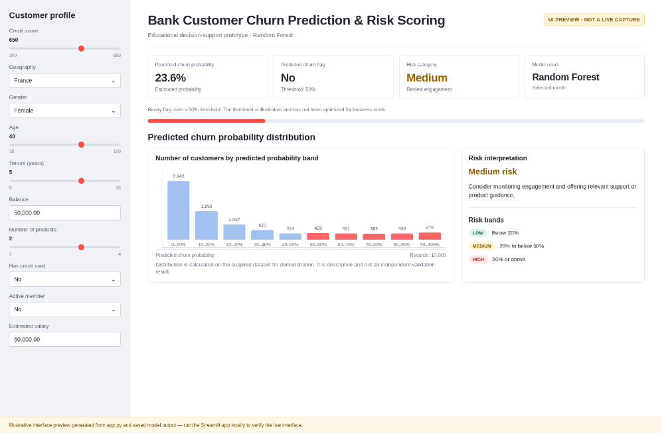

Screenshot 10.2: Customer input calculator —
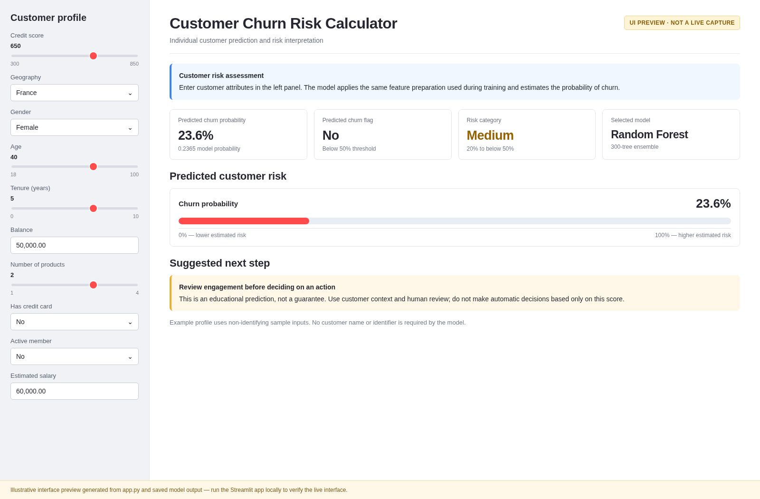

Screenshot 10.3: Feature importance section
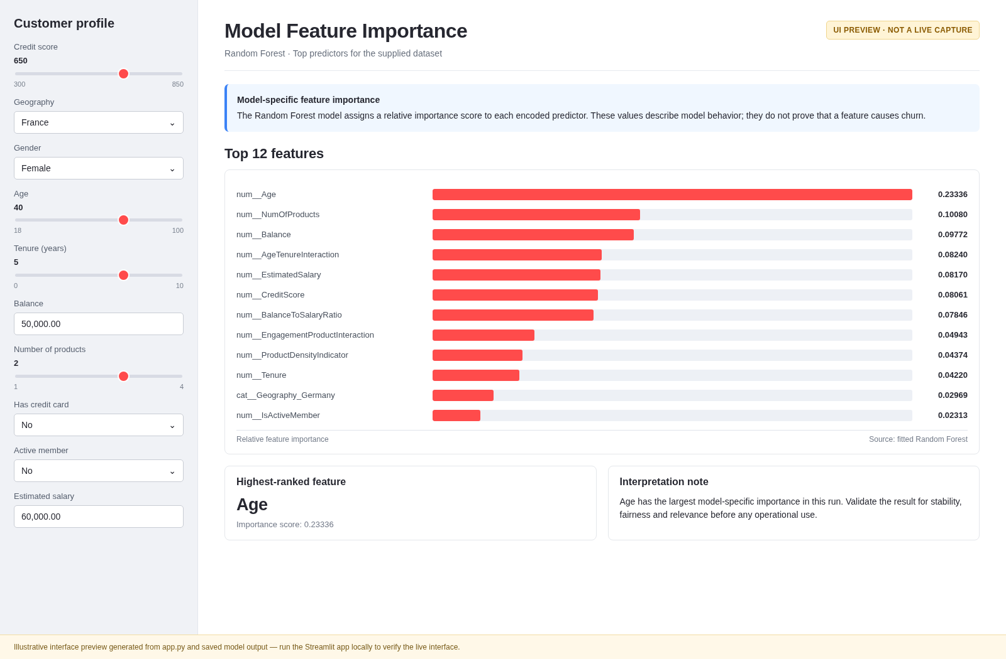

Screenshot 10.4: What-if simulator
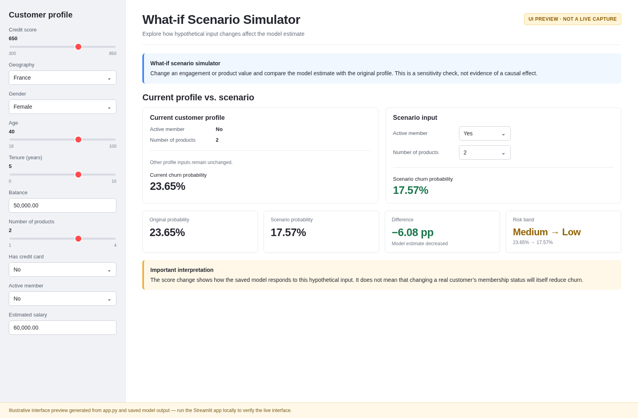

Screenshot 10.5: Batch scoring
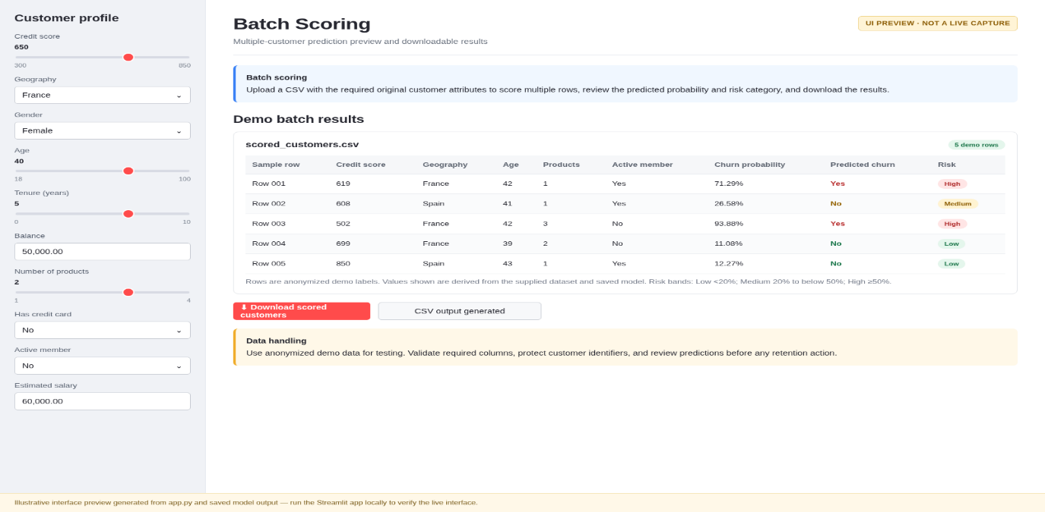
10.9 Application Limitations
The prototype is not authenticated, is not connected to a live database, and has not undergone security, privacy, accessibility, or production deployment review. Model artifact compatibility depends on library versions. Validate inputs, protect personal data, and test the complete application before demonstration.
The prototype demonstrates a workflow but does not establish production readiness. It may lack authentication, role-based access, encrypted storage, monitoring, audit logging, automated retraining, and formal model governance. It also depends on the quality and compatibility of the dataset and the saved model artifacts.
A real deployment would require security testing, privacy review, user acceptance testing, probability calibration, fairness assessment, drift monitoring, and a clear process for reviewing outcomes. The application should be treated as a proof of concept until these requirements have been addressed.

CHAPTER XI
FINDINGS, RECOMMENDATIONS, LIMITATIONS, CONCLUSION

11.1 Findings:
The study examined the application of machine learning techniques to bank customer churn prediction using the provided European bank customer dataset. The following findings were obtained from data preparation, model evaluation, risk scoring, and explainability analysis.
- Dataset distribution: The dataset contained 10,000 customer records. Of these, 7,963 customers (79.63%) stayed with the bank, while 2,037 customers (20.37%) exited.
- Data preparation: The dataset was prepared for supervised classification, and four engineered features were added: Balance_Salary_Ratio, Product_Density, Engagement_Product_Interaction, and Age_Tenure_Interaction.
- Model comparison: Four classification models were evaluated using an 80:20 stratified train-test split. The test dataset contained 2,000 records.
- Best overall evaluation: Gradient Boosting achieved the highest accuracy (87.05%), F1-score (60.82%), and ROC-AUC (0.8674) among the evaluated models.
- Precision: Random Forest recorded the highest precision at 79.40%, marginally above Gradient Boosting at 79.13%.
- Recall: Decision Tree achieved the highest recall at 76.66%, identifying more of the actual churners in the test set than the other evaluated models.
- Confusion matrix: Gradient Boosting correctly identified 201 churners and 1,540 retained customers. It also produced 53 false positives and 206 false negatives.
- Feature importance: The Gradient Boosting model's split-based feature importance ranked Age first at approximately 38.71% and NumOfProducts second at approximately 29.02%.
- SHAP analysis: Mean absolute SHAP values calculated on a sample of 500 test records also ranked NumOfProducts and Age prominently. This provides a second perspective on the magnitude of feature contributions.
- Partial dependence: The model's average predicted churn probability varied across age values and number-of-products values. The relationship was non-linear, and the results should not be interpreted as causal effects.
- Risk categories: Using provisional thresholds, 1,577 test-set customers were classified as Low Risk, 235 as Medium Risk, and 188 as High Risk.
- Practical relevance: The results demonstrate how machine learning can produce ranked churn-risk estimates and help organize customer records for further review. The study does not establish the effectiveness of a real-world retention campaign.
- Application development: A Streamlit dashboard, individual risk calculator, risk-driver interface, and what-if simulator are proposed application components. They should not be described as completed until a working application has been built and tested.
Overall, Gradient Boosting was selected as the preferred model for this experiment because it achieved the strongest combined results across accuracy, F1-score, and ROC-AUC. Model selection in a real banking setting would also need to account for probability calibration, retention costs, operational constraints, and performance on new data.
11.2 RECOMMENDATIONS:
Based on the results of the study, the following recommendations are proposed.
1. Use Gradient Boosting as the preferred experimental model
Gradient Boosting achieved the highest accuracy, F1-score, and ROC-AUC in the test-set comparison. It can therefore serve as the preferred model for further experimentation, subject to additional validation.
2. Consider the business cost of false negatives
The Gradient Boosting model missed 206 actual churners in the test dataset. A bank should evaluate whether reducing missed churners is more important than limiting unnecessary retention contacts. If identifying as many churners as possible is the primary objective, the Decision Tree's higher recall may deserve further consideration.
3. Validate risk thresholds before operational use
The Low, Medium, and High Risk thresholds of 0.30 and 0.60 were selected for demonstration. They should be evaluated using validation data, customer-retention costs, available intervention capacity, and the results of actual retention campaigns.
4. Validate probability calibration
Before interpreting predicted probabilities as reliable estimates of real-world churn likelihood, the selected model should undergo probability calibration assessment. Calibration methods may be evaluated using separate validation data.
5. Use explainability alongside predictions
Feature importance, SHAP analysis, and partial dependence can help analysts understand model behaviour. These techniques should support further investigation rather than being treated as evidence of causal relationships.
6. Develop and test the proposed Streamlit application
The proposed application should be implemented with input validation, consistent preprocessing, risk-category displays, model performance summaries, and clear explanations of prediction limitations. Individual predictions should be traceable to the model version and input data used.
7. Monitor performance over time
If the model is used operationally, its performance should be monitored as customer behaviour and banking conditions change. Revalidation and retraining may be necessary when the data distribution or prediction quality changes.
8. Protect customer information
Any future real-world deployment should follow applicable privacy, data-security, access-control, and governance requirements. Only authorized personnel should access customer-level risk information.
9. Conduct further validation
The model should be tested on additional or more recent customer data before use in a real banking environment. This would help establish whether the performance observed in the test dataset generalizes to new observations.
10. Evaluate business outcomes
Future research should examine whether model-guided retention activities reduce actual churn and provide benefits relative to their costs. Predictive performance alone does not establish that a retention strategy will be effective.
11.3 LIMITATIONS:
The study has several limitations that should be considered when interpreting its findings.
1. Dataset limitations
The analysis was based on the provided European_Bank.csv dataset. The findings reflect the variables and customer outcomes contained in that dataset and may not represent all banks, regions, customer groups, or time periods.
2. Limited information about the original data source
The project materials do not establish the original collection organization or the exact period during which the customer records were collected. Consequently, the results should not be generalized to a specific real-world bank without additional source verification.
3. Class imbalance
The target variable was imbalanced, with 79.63% of records representing retained customers and 20.37% representing exited customers. Although multiple evaluation measures were used, class imbalance may affect the interpretation of accuracy and other metrics.
4. Train-test evaluation
The models were evaluated using a single stratified 80:20 train-test split with random_state=42. Repeated cross-validation and evaluation on an independent external dataset were not included in the reported comparison.
5. Probability calibration
The predicted churn probabilities were used to create risk scores and categories. Independent probability calibration analysis was not performed, so the probabilities should be treated as model estimates rather than guaranteed real-world likelihoods.
6. Provisional risk thresholds
The Low, Medium, and High Risk thresholds were selected for demonstration. They were not optimized against retention costs, business constraints, or observed intervention outcomes.
7. Model interpretation
Feature importance, SHAP, and partial dependence describe aspects of model behaviour. They do not establish causation, and the interpretation may depend on the model, dataset, feature relationships, and analysis method.
8. Limited feature scope
The model uses only the available dataset variables and engineered features. Additional information such as customer complaints, service interactions, transaction patterns, product usage over time, and customer feedback was not included unless represented in the supplied data.
9. Application implementation
The current notebook contains model evaluation and risk-scoring logic, but it does not establish that the proposed Streamlit dashboard and all four application components have been completed and tested.
10. Business impact not measured
The study did not conduct a real-world retention campaign or measure changes in customer retention, revenue, or intervention costs. Therefore, the analysis demonstrates predictive potential rather than proven business impact.
These limitations indicate that the results are appropriate for an academic demonstration of churn prediction and risk scoring. Further validation, calibration, monitoring, and operational testing would be required before real-world use.

11.4 CONCLUSION
This study examined the use of machine learning for predicting bank customer churn and translating predicted probabilities into an understandable risk-scoring framework. The analysis used the provided European bank customer dataset, containing 10,000 records and the target variable Exited.
The dataset was prepared for supervised classification, and four machine learning algorithms were evaluated: Logistic Regression, Decision Tree, Random Forest, and Gradient Boosting. The models were compared using accuracy, precision, recall, F1-score, ROC-AUC, and confusion matrices.
Among the evaluated models, Gradient Boosting achieved the highest accuracy of 87.05%, F1-score of 60.82%, and ROC-AUC of 0.8674. Random Forest achieved the highest precision at 79.40%, while Decision Tree achieved the highest recall at 76.66%. These results demonstrate that model performance depends on the evaluation measure and the objective of the intended application.
The Gradient Boosting model was further examined using feature importance, SHAP analysis, and partial dependence. Age and number of banking products were prominent in the feature importance and SHAP analyses. Partial dependence results indicated that the model's estimated churn probabilities varied across selected customer attributes. These results describe model behaviour and should not be interpreted as proof that the variables cause churn.
A provisional risk-scoring framework was established by converting predicted churn probabilities into scores from 0 to 100 and assigning Low, Medium, and High Risk categories. On the 2,000-record test dataset, 1,577 customers were classified as Low Risk, 235 as Medium Risk, and 188 as High Risk using the selected thresholds.
The study demonstrates how machine learning can support the analysis of customer churn, the ranking of estimated risk, and the interpretation of prediction patterns. However, the risk thresholds require validation, predicted probabilities require calibration assessment, and the preferred model should be tested on additional data before practical deployment.
A Streamlit dashboard with a risk calculator, risk-driver explanations, and a what-if simulator has been proposed as a way to make the results accessible to users. These components should be reported as implemented only after a working application has been developed and tested.
In conclusion, the project provides an experimental framework for predictive customer churn analysis and risk scoring. Further validation, responsible use of customer data, monitoring, and evaluation of real-world retention outcomes are necessary before the approach can be relied upon in an operational banking environment.

REFERENCES
Use the following references if these methods and tools are retained in your final project. Keep only references that you actually consult and use; also retain any valid sources already cited in your literature review.
- Breiman, L. (2001). Random Forests. Machine Learning, 45, 5–32. https://doi.org/10.1023/A:1010933404324
- Friedman, J. H. (2001). Greedy function approximation: A gradient boosting machine. The Annals of Statistics, 29(5), 1189–1232. https://doi.org/10.1214/aos/1013203451
- Lundberg, S. M., & Lee, S. I. (2017). A unified approach to interpreting model predictions. In Advances in Neural Information Processing Systems 30 (pp. 4765–4774).
- Pedregosa, F., Varoquaux, G., Gramfort, A., et al. (2011). Scikit-learn: Machine learning in Python. Journal of Machine Learning Research, 12, 2825–2830. https://jmlr.org/papers/v12/pedregosa11a.html
- Scikit-learn developers. (n.d.). Scikit-learn documentation. https://scikit-learn.org/stable/
- SHAP developers. (n.d.). SHAP documentation. https://shap.readthedocs.io/
- Streamlit. (n.d.). Streamlit documentation. https://docs.streamlit.io/
- Molnar, C. (n.d.). Interpretable Machine Learning. https://christophm.github.io/interpretable-ml-book/
- European_Bank.csv. Dataset supplied with the project materials.
- European_Bank_Feature_Engineered.csv. Feature-engineered dataset used for model development and evaluation.
- Project_1 (1)(1).ipynb. Jupyter Notebook containing the data preparation, model training, evaluation, and risk-scoring workflow.

APPENDIX
The appendices provide supporting information for the analysis presented in the main chapters.
Appendix A: Dataset Variables
Include the data dictionary for the variables used in the project, including CreditScore, Geography, Gender, Age, Tenure, Balance, NumOfProducts, HasCrCard, IsActiveMember, EstimatedSalary, and Exited. Also include the four engineered features: Balance_Salary_Ratio, Product_Density, Engagement_Product_Interaction, and Age_Tenure_Interaction.
Appendix B: Data Preparation and Feature Engineering
Include relevant notebook code and output showing duplicate handling, feature creation, missing-value checks, categorical encoding, numerical scaling, and the final model input structure.
Appendix C: Model Training Configuration
Include the model definitions and training settings for Logistic Regression, Decision Tree, Random Forest, and Gradient Boosting. State the stratified 80:20 train-test split, random_state=42, and the preprocessing pipeline.
Appendix D: Model Evaluation Outputs
Include the complete model comparison table, confusion matrices for all four models, the ROC curve comparison, and any classification reports generated by the notebook.
Appendix E: Model Explainability
Include the feature importance chart, SHAP summary or bar chart, and partial dependence plots for Age and NumOfProducts. State that SHAP values were calculated on a sample of 500 test records if that is the version retained in the final analysis.
Appendix F: Churn Risk Scoring
Include the risk-category summary, the probability-to-score formula, the provisional thresholds, and a small sample of anonymized risk-score records. Do not include unnecessary personal identifiers.
Appendix G: Streamlit Application
If implemented, include screenshots of the Executive Dashboard, Risk Calculator, Risk Drivers, and What-if Simulator. If the application has not been built, label this appendix as proposed work or omit it according to the college's project requirements.
Appendix H: Supporting Files
List the final dataset, feature-engineered dataset, Jupyter Notebook, model comparison output, and risk-scoring output included with the project submission.

